Instruction for iPhone

brief introduction
The documents mainly introduces how to set and use the Software for iPhone OS.

The Software has some main functions.
- Browse real time video function;
- Cloud stand control function (the front end is to control ball machine).

Essential condition

Need iOS 3.0 or higher release, the cellular phone includes iPhone, the iPod touch waits

Install and operating instructions
- Circulate iPhone App Store procedure, cut over the huning label page, search to input TMEye+ in the column, will find out to apply a procedure setup to wrap, click to carry on a setup then.

- Will appear a routing diagram mark after the setup, the following chart
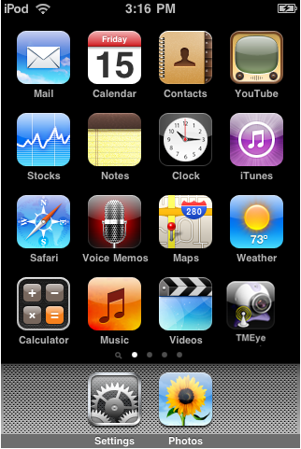
- Click a homologous routing diagram mark, circulate after the procedure a beginning to start interface the following chart
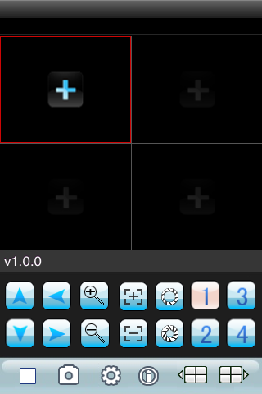

- Press button vs in response to the function is as follows
Function key | name | Function description
 | play | The procedure connectivity equipment combines to start broadcasting a video
 | snap | Grasp beats  snap Grasp to clap a current ICON(grasp a chart document to recognize tacitly conservancy to the cellular phone of tacit approval of photograph catalog bottom.)
 | setting | Establish a DVR IP address or watch an area, port, user's name and password and equipment alias information
 | Up group | Can select up the gang gateway
 | Next group | Can select to descend gang gateway
 | About | About information
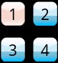 | Selective channel | Select gateway  Selective channel Select a some video of one gateway that broadcasts an equipment.Can carry out eight roads, 16 road gateways to cut over with"descend gang" team work
 | PTZ control | Carry out a cloud on the stage, next, left and right control
 | Zoom ratio | The realize tension far draws near
 | focus | Carry out focal length to add and subtract
 | aperture | Carry out diaphragm to add and subtract

- Such as first time use or need to carry on parameter to change, please click 【setup 】button enter a parameter setup interface.The following chart
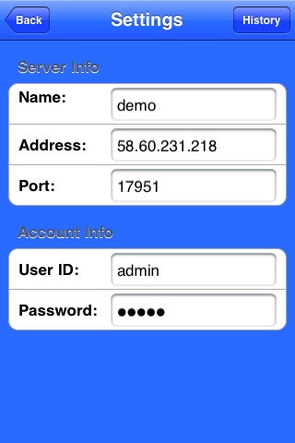

：
explain

Server address(Address):DVR male net IP address or dynamic state area

Server port(Port):In DVR setup ascend specialized give the port of cellular phone

Equipment denomination(DeviceName):The alias of equipment is easy to classify several equipments

User's name(User ID):The user's name reconciliation that carries a setup with IE

Password(Password):The password reconciliation that carries a setup with IE
Is a return button
Enter a history record page
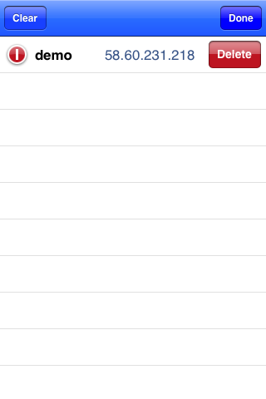

- Pick out in the history record a certain click and then can carry on the watch a dot of watch

- Delete a certain history record

Lightly sweep a certain record, click again 【Delete】button, can immediately delete an equipment, the following chart:

The DVR parameter that favors a cellular phone establishes a referenc
Resolution:CIF or QCIF
Leads:5-1
The code flows a type:Limit
The code flows:64-256Kb/S
Note:Can carry on tune according to the cellular phone performance and the network condition.Higher cellular phone performance and network condition can display better effect.If the network condition is worse, can appropriately the step - down lead and assure flowing freely

