IP address and ports mapping in the router
1.Set DVR IP address,TCP port,HTTP port and Mobile port.

(1) IP address,TCP and HTTP port,see below picture:
DVR IP address
Router IP address
(2) Set Mobile Monitor port,see below picture:
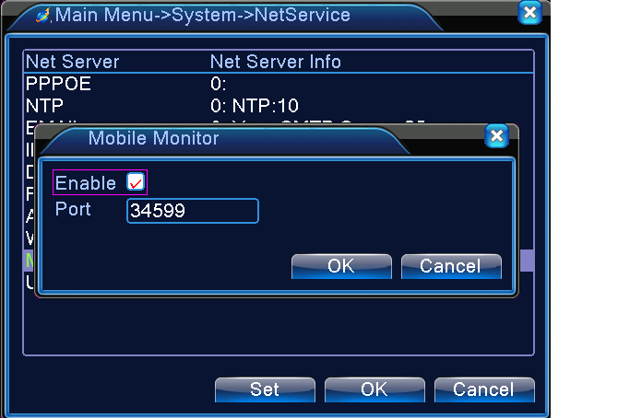

2. If there is only 1 DVR in the router,find your router ip address and visit it,then go to DMZ to input DVR IP address,see picture as below:
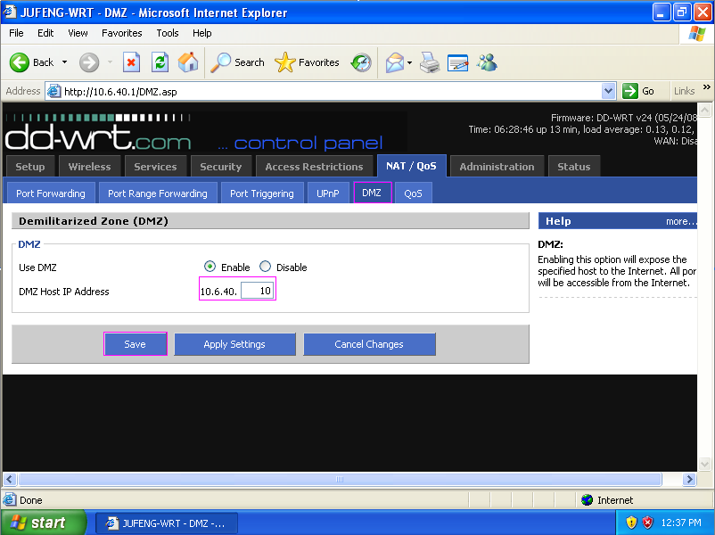
Input DVR IP address,then click "Save".

3. If there are multi DVR in the router,then set IP address and ports mapping as below picture:

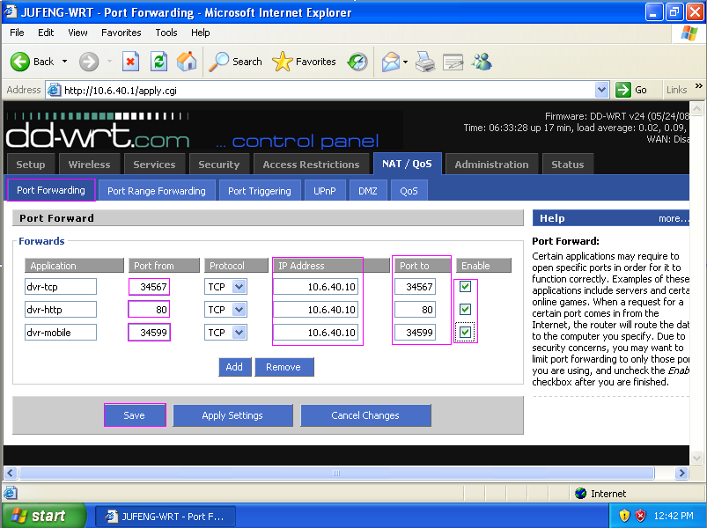
TCP port
HTTP port
Mobile Monitor port
DVR IP Address

After input the above parameters,then click "Save".

- IE,CMS and mobile remote view.
IE Browser: http://10.6.40.10:80
CMS: IP address: 10.6.40.10
Port: 34567
Mobile: IP server: 10.6.40.10
Port: 34599
For iPhone,pls use mobile to search "vMeye" in the www.appstore.com and install it online.

