VMEYE
For Android
User Manual

User Manual Version 1.0 (July, 2011)
Please visit our website www.meyetech.com

Contents

Chapter One Introduction………………………………….2
1.1Brief Introduction…….………………………………......…2
1.2Essential Condition………………………………......…..2
Chapter Two Acquisition and Installation………………......3
2.1 Acquire Vmeye from Android Market（E-Market）…..3
2.2 Acquire Vmeye from Suppliers or manufacturers4
Chapter Three Application Running…………………........5
3.1 Interface Description……………………………….............5
3.2 Functions of Corresponding Buttons………………........….5
3.3 Detailed Setting Introduction………………………….........7
3.4 Video Display………………………………………............8
Chapter Four FAQ…………………………………….........9

Chapter one Introduction

1.1 Brief Introduction
This document mainly introduces how to set and use Vmeye for Android OS
Vmeye has three main functions.
- Realize real-time video watching function;
- PTZ control function (the device must be supported).
- Up to 16 channels switching.
In a word, our product enables you to process real-time video monitoring under normal network condition, which can help protect important property.

1.2 Essential Condition
This application supports Android system that is higher than 1.5 released, these cellular phones include HTC G1、HTC Magic、HTC Hero、HTC G5 etc. Other brands of Android phones such as Motorola, Samsung and so on are all favored by Vmeye

Chapter two Installation

2.1 Acquire Vmeye from Android Market
Our users can acquire Vmeye either through downloading from Android Market or from the DVR manufacturers.
As downloading from Android Market, you may first search “Vmeye”, and install it on line, as the following picture shows:

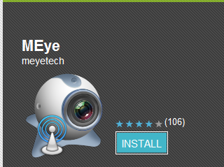 (Picture 1)
Then click “Install”, the application will be automatically installed into your mobile phone, just like the below picture shows:
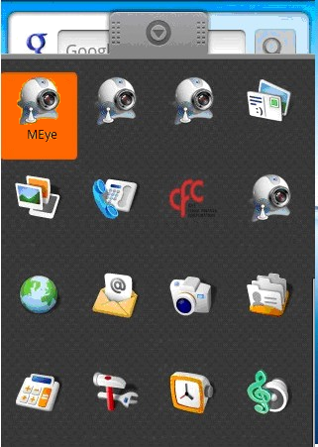 (Picture 2)
This means this application is successfully installed.

2.2 Acquire Vmeye from suppliers or manufacturers
If you purchase DVR devices from suppliers or manufacturers, this application will be enclosed in the DVD disk. You only need to copy Vmeye into the mobile phone and click to install it, and then the icon of this application will appear in the menu as above picture shows.

Chapter Three Application Running

3.1 Interface Description
After successfully installed the application into mobile phones, it is ready to run, just click the Vmeye icon in the main menu.

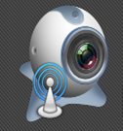
(Picture 3)
The main interface looks like this:
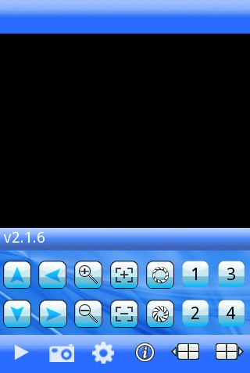
You can see all the buttons appearing in the interface, as well as the version number.
(Picture 4)

3.2 Functions of corresponding buttons
There are many buttons in the main interface, here is the instruction for their functions. See table 1 below:

Function key | Name | Function description
 | Play | The procedure to start broadcasting a video camera
 | Snap pictures | To grasp a picture document appearing in the camera and save it the installed folder.
 | Setting | Enable users to edit DVR IP address, port, user's name and password setting and the change of equipment alias and watching area switch.
 | Up group | Select to the pre-group of gateways
 | Next group | Select to the next group of gateways
 | About | Application information
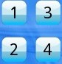 | Select channel | Enables to select a certain video of one gateway that broadcasts equipment to another. It can carry out eight roads one time, click "next group" button for the next eight roads.
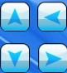 | PTZ control | Carry out PTZ control
 | Zoom control | To draw the camera from close to farther distance
 | Change focus | Carry out focal length from adding to subtracting
 | Aperture changing | Carry out diaphragm from adding to subtracting
(Table 1)

These are the functions of the buttons, we truly hope this instruction table can be a guidance for you.

3.3 Detailed setting introduction
If this is the first time using Vmeye, you need to put in all the information needed. In this part, our introduction may provide you some useful information.
First, please click setting button () in the main interface. And then the following picture will show:
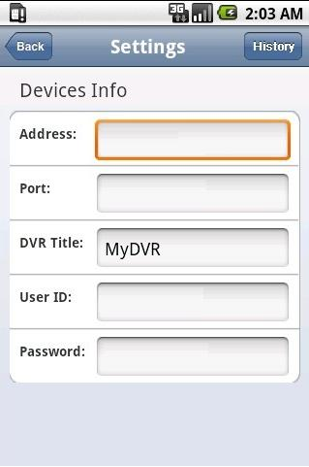
We can see five lines of blank needed to be filled. They are Address, Port, DVR title (Names), User ID and Password. We will explain what they mean and you should pay attention to.
(Picture 5)
Server address (Address): DVR IP address or DDNS. (Must be an Internet address)
Server port (Port): It means mobile phone port, you can acquire port number from the setting information of the device
DVR titles (Device Name): The names of equipment, which can be
classified with different devices, for examples, you can type the names based on the location of the equipment.
User's name (User ID): Usually the default is "admin", please consult your suppliers for more detail.
Password: The default of password is usually as "admin", the same as the ID.
You can edit and manage your access book by clicking “History” button in the right top.
The above information can almost help all the users, if there is still problem, you can ask the suppliers or write e-mails to our technical supporter.

If you still have problem in this section, please visit our website www.meyetech.com for more information.

3.4 Video display
This application can both support routine mode and full-screen mode, when the mobile phone lies down horizontally, the application will automatically play in full-screen mode.

Chapter Four FAQ

In this section, we will conclude some frequently appearing problems and solution for users, for more information and interaction with us, you can visit: www.meyetech.com, which provides the latest information and versions of software, you can also directly submit your questions to us through: Support ——> Submit Online;

Q1: What is the function of Vmeye series applications?
A1: Vmeye series applications enable users to view their IP cameras or DVRs with their mobile phones remotely and real time.

Q2: Where can I find the apps?
A2:
- You can download apps in the E-markets of corresponding mobile OS with keywords “Vmeye” or the name of the app, such as “HB player” and so on; presently, you can visit:
http://appworld.blackberry.com for Blackberry;
https://market.android.com for Android
http://applestore.com/itunes/ for Iphone
- You can get the apps from your device seller, which will be attached

in the DVD of the devices.
Q3: Will I be charged for the data when I use the apps?
A3: If you use our software via WiFi connection, you will not be charged for data connection. But if you use GPRS or 3G network, you will be charged, you can ask your local mobile operator for detailed information.

Q4: What types of mobiles can I use with Vmeye series applications?
A4: Our products mainly support five main mobile OS, which are Android, Iphone, Blackberry, Windows and Symbian, other OS will be gradually added.

Q5: What is a port?
A5:
- A port is a “tunnel” through which the device exchanges data with the Internet.
- It is notable that a mobile port is different from a PC port; you can find out the mobile port in your device’s setting menu or ask the device suppliers because the mobile port is initially fixed by them.

Q6: Where do I get my User ID or Username and Password?
A6: Normally they are provided by your DVR suppliers, you can ask them for help. The default of User ID and password are usually “admin” and “admin”.

Q7: Why there is nothing showing after I have connected?
A7: This problem may be caused by the wrong settings of the input of mobile phone’s port. You can ask the DVR suppliers for help because the port is fixed by them.

Q8: How often can I update my app?
A8: Normally we will update the apps every one or two months online, to gradually solve the problem caused by the app itself and provide better service to you. Please visit our web: www.meyetech.com often to update your apps in time!

Q9: What should I do to ensure the app work well on my phone?
A9: To make sure that the app can run well on your phone, you had better pay attention to:
- Your device is compatible with our apps, you can visit www.meyetech.com to check the compatible devices list or you can

directly ask your device seller for help.
- Make sure that your phone model is supported by our apps, you can also visit www.meyetech.com to check the support phones list.
- Make sure that you are using the right app for your device, you can ask for help from our supporters and we will give you advices.
- That’s all and you will own an excellent experience with our apps!

Q10: What are the supported DVR devices of your software?
A10: We support certain device manufacturers that cooperate with us, which means our apps will run well on certain DVR models or IPcameras；For further details，please visit www.meyetech.com to get a complete list for compatible devices information.

