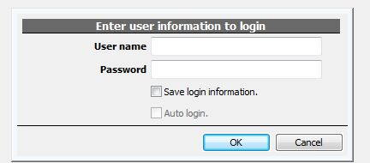
After open the sofeware, this dialog will be shown, and the default usename:admin password:1234

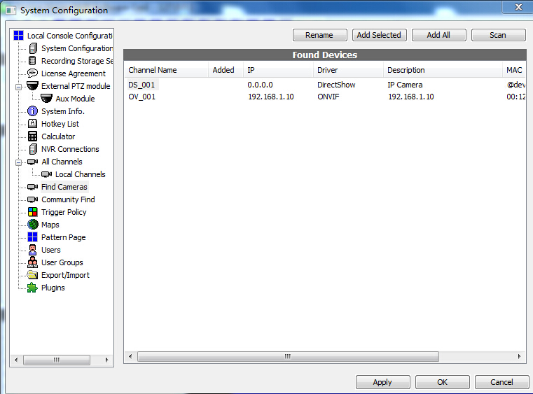
Click  Log in camera Settings interface,
Search the IP address of the camera and add it.
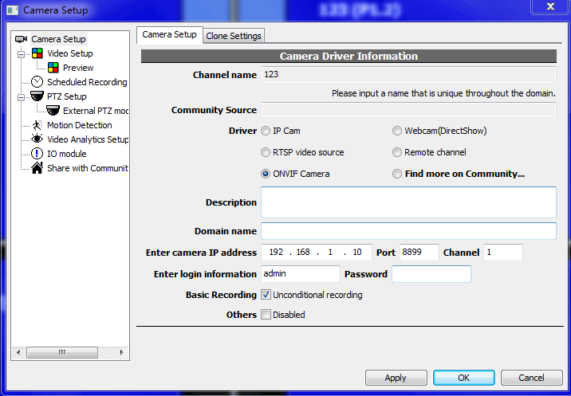
As the picture, Choose onvif camera, ip address: 192.168.1.10 port：8899 Usename: admin no password

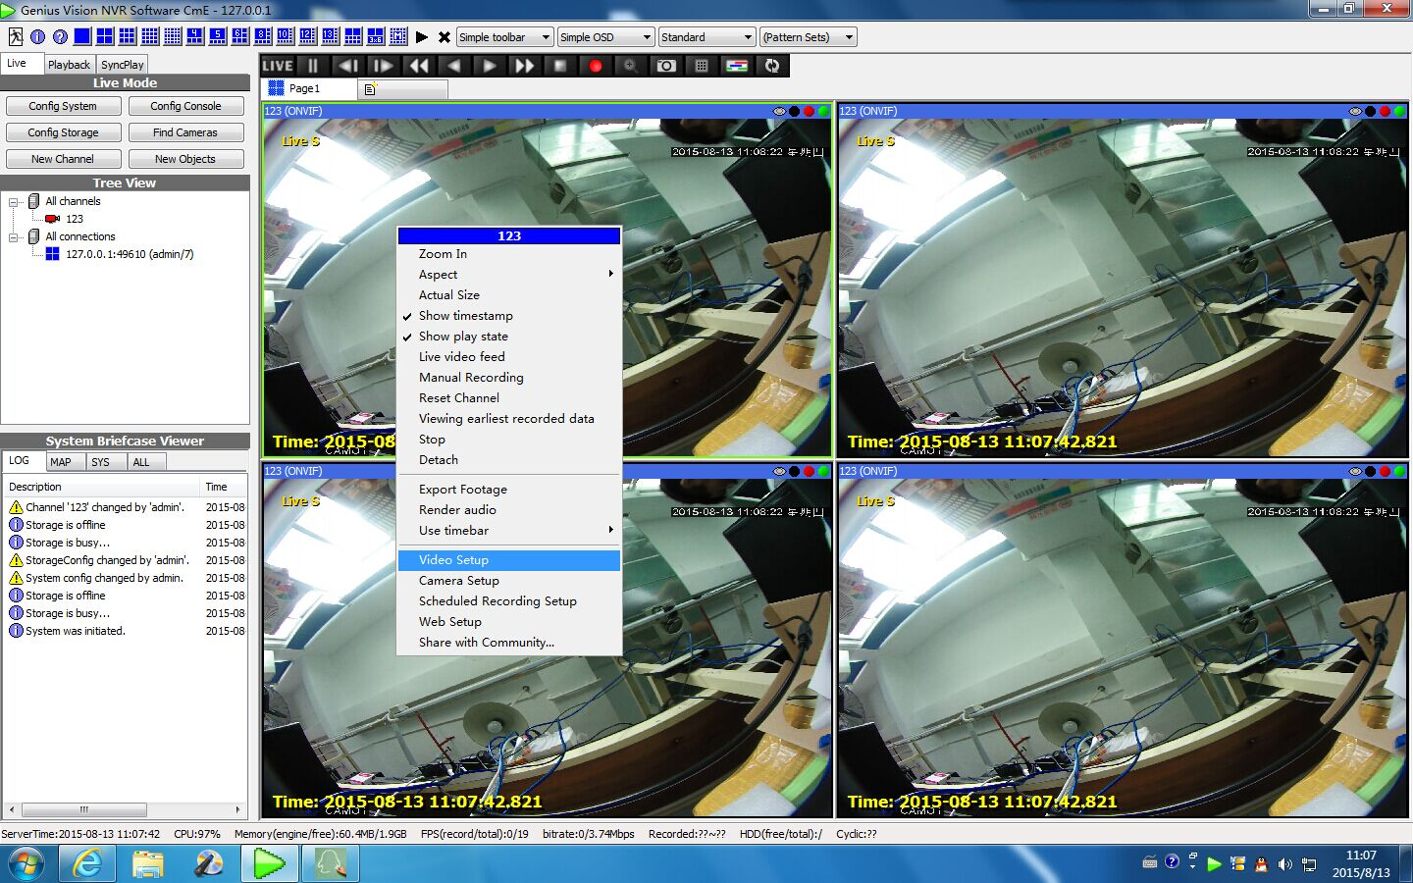
After the picture showing,you can select video options for image segmentation(board view)

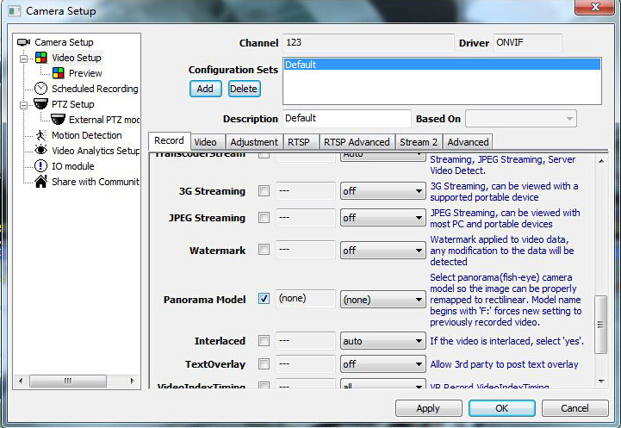
As the picture ,find panorama model , and choose it

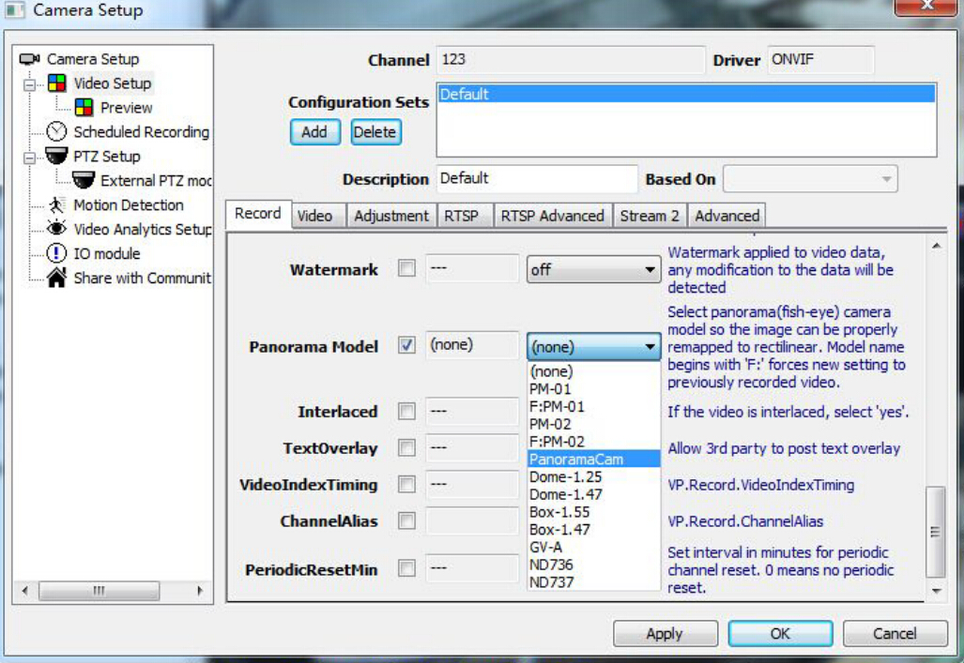
Choose PanoramaCam, and then click OK
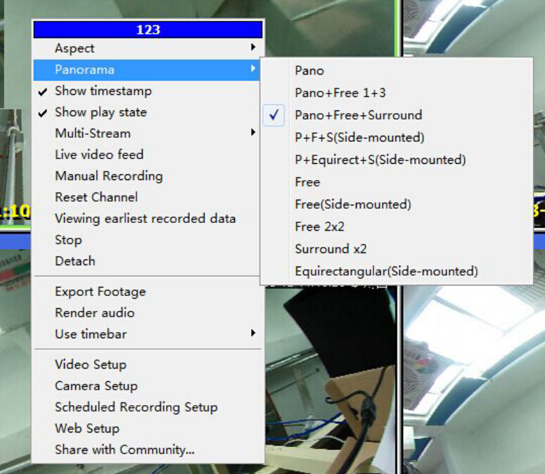
Right Click,
Then through the panorama option, you can choose the split screen type you want.

