FK02GYW安装部署使用指南文档
FK02GYW Installation and operation instructions

- 智能终端2000平台软件安装部署，请参考《智能终端2000快速操作手册》
- Smart terminal 2000 platform software installation and deployment, please refer to "Smart Terminal 2000 Quick Operation Manual".

- 设备安装注意事项
2.Equipment installation precautions.
- 测温计需要固定安装
1) The thermometer needs to be fixed.
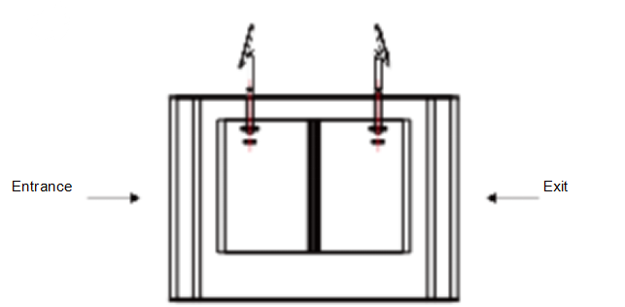
- 闸机上开一个直径D=35mm孔，建议位置距离入口端1/3至1/4处；
Open a hole with a diameter of D = 35mm on the gate, and the recommended position is 1/3 to 1/4 from the entrance device;
- 将设备安装支架插入闸机开孔内，从闸机内部固定设备螺母；
Insert the equipment mounting bracket into the opening of the gate and fix the equipment’s screw nut from the inside of the gate;
- 将设备调整至合适角度（垂直5°-15°夹角）。
Adjust the device to a suitable angle (angle between 5 ° -15 ° vertical)

如果需要临时测试，那么也需要使用固定杆固定，不建议手持
If temporary testing is needed, it is also necessary to use a fixed rod to fix it. It is not recommended to hold it by hand.

- 测试标志地板距离，保证测试准确性
Test the floor distance to ensure the accuracy of the test.
- ST02测温距离:0.5-1.3米0.75米测试最佳，
Temperature measurement distance: 0.5m -1.3m, 0.75m is the best testing distance.
- 测温机上电开机后，需要先暖机20分钟再进行测试（测温模块需要暖机才能测温准确）,20分钟是最大值，在20分钟内如果落到正常体温36.5，即可认为暖机完成
After the temperature measuring machine is powered on, it needs to be warmed up for 20 minutes before testing (the temperature measurement module needs to be warmed up to measure the temperature accurately). 20 minutes is the maximum value. If it falls to a normal body temperature of 36.5 within 20 minutes, it can be considered warm up process completed.
- 测温时，尽量固定终端，不要手持来回晃着测试，人测试时额头也不要老是晃，尽量静止下来再测试
When measuring temperature, try to fix the terminal as much as possible, do n’t shake it back and forth by hand, and don’t shake your forehead when testing.
- 有刘海的，尽量掀起刘海，不要让额头有头发残留，因为测温区域测的是最高值，头发可能会比额头温度高
If you have bangs, try to raise the bangs as much as possible. Do not let hair remain on the forehead, because the highest value is measured in the temperature measurement area, and the hair may be higher than the forehead.
在安装固定好测温机后，在地板标志距离贴纸，贴上0.75米，1米等距离，然后测试时，人体需要站在对应的位置进行测试人脸识别和温度测温功能，如下图所示
After installing and fixing the temperature measuring machine, put a sticker to mark on the floor, and affix an equal distance of 0.75 meters, 1 meter, and then test, the human body needs to stand at the corresponding position to test the face recognition and temperature measurement function, as shown in the below photo
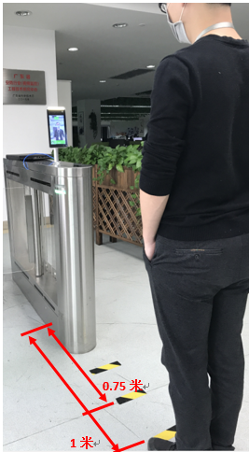
在按照以上定点标志站立测试时，就可以避免出现因为距离不对而影响测试的结果，测试时人脸不能有超过测温机屏幕显示的绿色人脸框，必须完全在屏幕中显示的人脸框内，实际人脸的大小在屏幕中占比如下图所示是正确的测试距离，如果距离太近，如手持的话，会出现人脸超过屏幕显示的人脸框，就容易出现测试不准确。
When stand and test according to the above fixed-point marks, you can avoid affecting the test results due to the wrong distance. During the test, the face cannot have a green face frame that exceeds the screen of the thermometer. The actual face size on the screen is as shown in the figure below. It is the correct test distance. If the distance is too close, such as holding it, a face frame will appear over the screen.
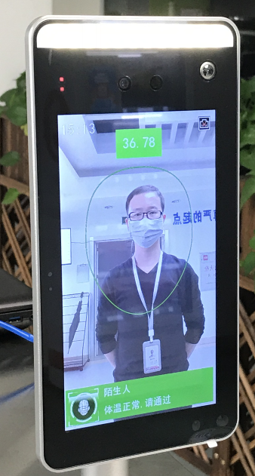
注意：在测试和实际安装使用时，测试对象和测温计都需要远离热源（空调出风口，微波炉，暖风机等），如果有热源在附近，安装时也需要和热源保持有至少3米以上的距离。
Note: During the test and actual installation, the test object and the thermometer should be kept away from the heat source (air conditioner air outlet, microwave oven, heater, etc.). If there is a heat source nearby, it must also be kept at least 3 meters away from the heat source during the installation.

