Новител ЕООД
В.Търново ул.Мом.крепост 8 тел.0879600444 sava@topalov.com www.topalov.com
IP видеокамери Cantonk:
H264 / H265/H264+/H265+ Hikvision / XM / ONVIF съвместими
Тези камери имат пълна функционална съвметимост с всички ONVIF устройства.
В режим „HIK ptotocol enable” те са напълно съвместими с H264/H264+ и H264/H264+/H265/H265+ видеорекордерите на Hikvision , както и със софтуера iVMS4200 / iVMS4500, вкл. функцията детекция и запис на движение.
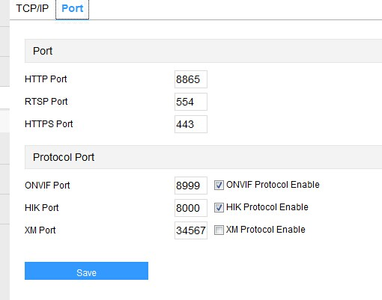
В режим „XM ptotocol enable” те са напълно съвместими с всички H264 и H265 XM базирани видеорекордери, както и със софтуера CMS3.1xxx, CMS2.0xxx, vMEye_super, XM eye, вкл. функцията детекция и запис на движение.

камера | описание | цена лв с ДДС
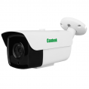  IP-CW60-HHL200  IMX307 + Hi3516EV200 | 1/2.8" SONY Starvis Back‐illuminated CMOS Sensor  HISILICON Hi3516E V200, WDR ; Starlight  Main Stream: 1080P@25fps; 3MP F1.6 HD Lens, With IR‐CUT  Plastic & Weatherproof IR Camera IP66  Anti‐Cut 3‐Axis Metal Bracket Size:162 x 88 x 86(D)mm Weight: 600g  IR LED: 42μ x 4PCS IR range: 60M  Board Lens : 2,8 , 3,6, 6 mm | 165
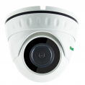  IPSL20HL200  IMX307 + Hi3516CV300 | 1/2.8" SONY Starvis Back‐illuminated CMOS Sensor  HISILICON Hi3516C, WDR ; Starlight  Main Stream: 3MP@15fps/1080P@30fps; 3MP F1.6 HD Lens, With IR‐CUT  IR LED: 14μ x 18PCS IR range: 20m Water resistance: IP66, DOME Alum.case, 95 X 76 mm  Lens 2.8 / 3,6 / 6 mm 4x AF  http://www.cantonk.com/product/NetworkCameras/2MPSeries/FixedLensDome/2017/0803/1921.html | 135
IP-PTN60HL200  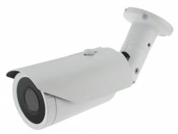  IMX307 + Hi3516CV300 | 1/2.8" SONY Starvis Back‐illuminated CMOS Sensor  HISILICON Hi3516C, WDR ; Starlight  Main Stream: 1080P@30fps; 3MP F1.6 HD Lens, With IR‐CUT  Plastic & Weatherproof IR Camera IP66  manual zoom lens 6 - 22 mm  http://www.cantonk.cn/uploadfile/cantonk/specification%20-%20PDF/Network%20Cameras/2MP%20201706/bullet/IP-PTN60-2MP.pdf | 200
IPTA30HL200  IMX307+Hi3516CV300 | 1/2.8" SONY Starvis Back‐illuminated CMOS Sensor  HISILICON Hi3516C, WDR ; Starlight  Main Stream: 1080P@25fps; 3MP F1.6 HD Lens, With IR‐CUT Board Lens 2.8 / 3.6 mm/F2.0  IR LED: 42μ x 4 PCS  Water resistance: IP66 Alum. case  Anti‐Cut 3‐Axis Bracket  Size: 170(W)x75(H)x77(D)mm, Weight: 750g | 165
IPTA30HP200  IMX327+Hi3516CV300 | 1/2.8" SONY Starvis Back-illuminated CMOS Sensor  HISILICON Hi3516C, WDR ; Super Starlight  Main Stream: 1080P@25fps; 3MP F1.6 HD Lens, With IR‐CUT Board Lens 2.8 / 3.6 mm  IR LED: 42μ x 4 PCS  Water resistance: IP66 Alum. case  Anti‐Cut 3‐Axis Bracket  Size: 170(W)x75(H)x77(D)mm, Weight: 750g | 180
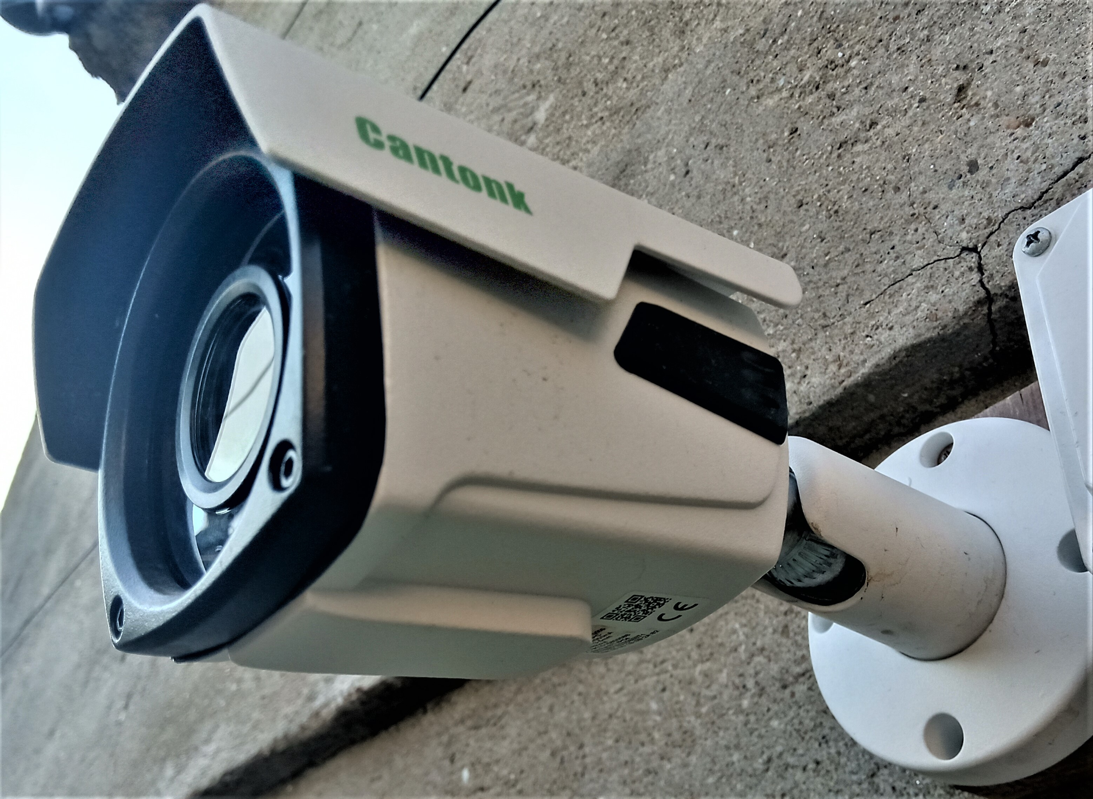  IPBQ60HS500  IMX335 + Hi3516D  2.7-13.5 mm 5X AF | 5 Mp 1/2.8" SONY Starvis Back-illuminated CMOS sensor  HISILICON Hi3516D, DWDR; With IR-CUT Including Internal POE  Main Stream: 5MP@20fps, 4MP@25fps, 1080P@30fps; 5MP HD Lens  2.7-13.5mm Motor Zoom Auto Focus Lens | 225
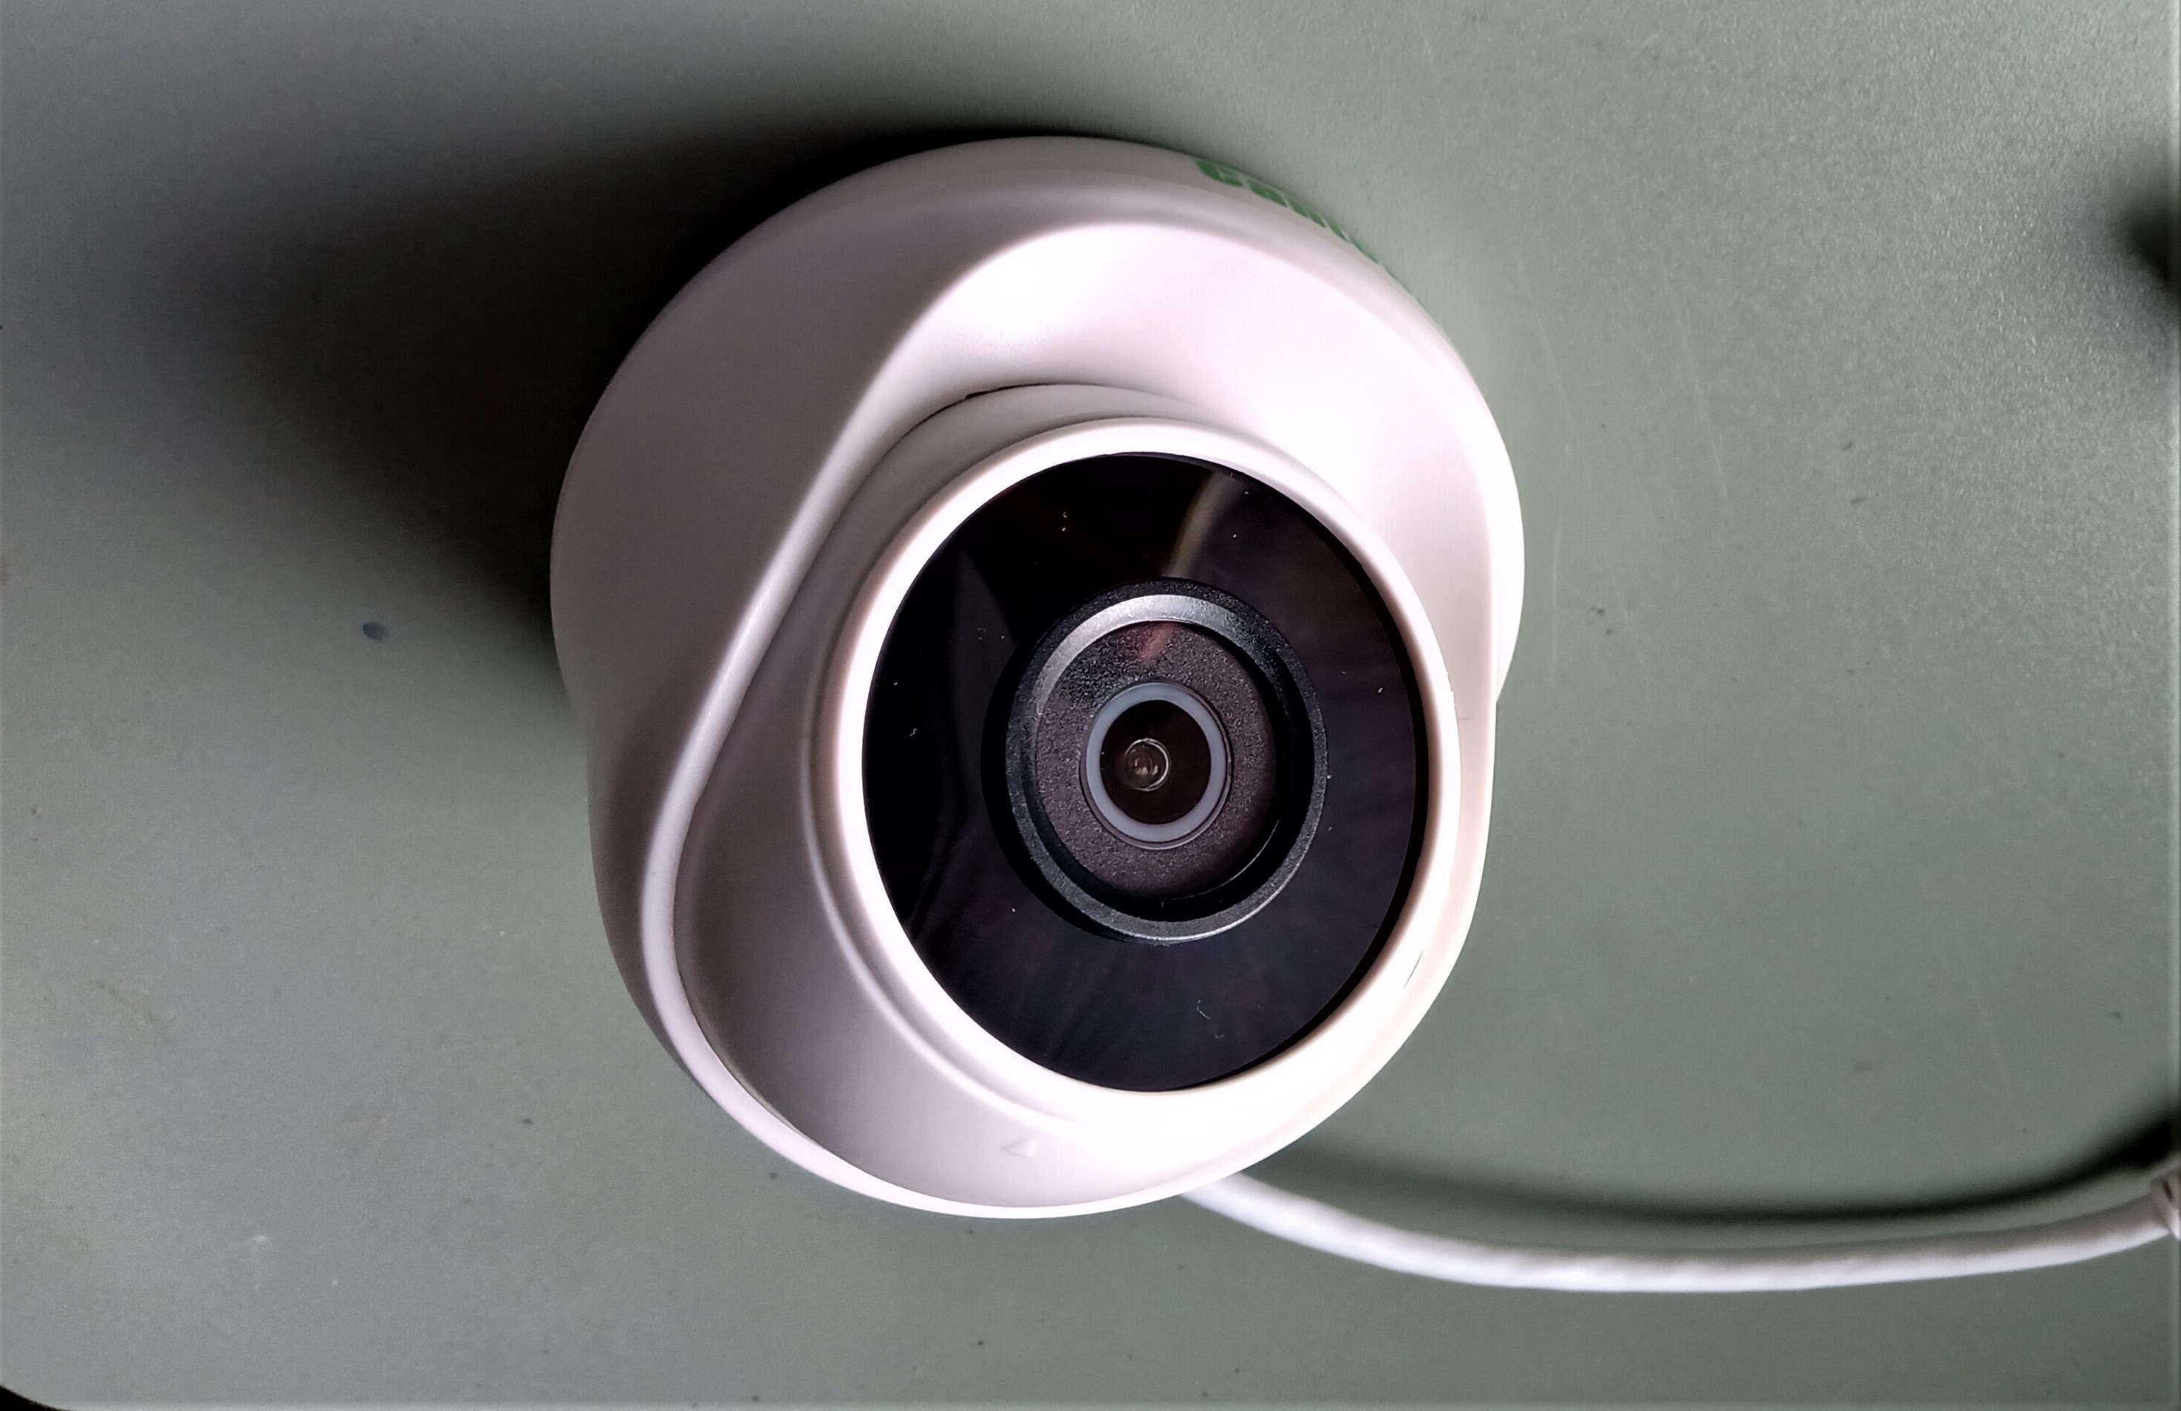  IPCDPHL200  IMX307 + Hi3516CV300 | 1/2.8" SONY Starvis Back-illuminated CMOS Sensor  HISILICON Hi3516C, WDR; Starlight  Main Stream: 1080P@25fps, 3M@15fps;  3MP F1.6 HD Lens, With IR-CUT 2.8 / 3.6 mm  Plastic IR Dome Camera  IR LED: 14μ x 18PCS  92(W) x 79(H) x 92(D)mm | 125

IP ВИДЕОРЕКОРДЕРИ
номенклатура | характеристика | LAN/Internet access: | цена лв  с ДДС
NVR5116PF  XM | 16*1080P /16*960P, Hi3536C ,2xHDD, HDMI/VGA/1080p  10/100/1000 MBps LAN 12V/2A power adapter  XM software H264/H265 | port 34567  vMeye super,  CMS3.1.0.8  ONVIF | 180
NVR5132PF  XM | 32*1080P /32*960P, Hi3536,2xHDD, HDMI/VGA/1080p  10/100/1000 MBps LAN 12V/2A power adapter  XM software H264/H265 | port 34567  vMeye super,  CMS3.1.0.8  ONVIF | 260
DS7608NI-Q1  Hikvision | 8x 1080p@30fps 1 x HDD  Hikvision software , H264/H265/H264+/H265+  https://www.hikvision.com/europe/Products/Network-Video-Recorder/7600/DS-7608/7616NI-Q1 | port 8000  iVms 4200  iVms 4500  ONVIF | 216
DS7616NI-K2  Hikvision | 16x 1080p@30fps 2 x HDD  Hikvision software , H264/H265/H264+/H265+  https://www.hikvision.com/europe/Products/Network-Video-Recorder/7600/DS-7608/7616NI-K2 | port 8000  iVms 4200  iVms 4500  ONVIF | 396
DS7616NI-Q1  Hikvision | 16x 1080p@30fps 1 x HDD  Hikvision software , H264/H265/H264+/H265+  http://www.sectron.com/bg/product/8456/ds-7616-ni-q1 | port 8000  iVms 4200  iVms 4500  ONVIF | 255
DS7716NI-K4  Hikvision | 16x 1080p@30fps 4 x HDD  Hikvision software , H264/H265/H264+/H265+  https://www.hikvision.com/europe/Products/Network-Video-Recorder/7700/DS-7716/7732NI-K4 | port 8000  iVms 4200  iVms 4500  ONVIF | 690
DS7608NI-Q1  Hikvision | 4x 1080p@30fps 1 x HDD  Hikvision software , H264/H265/H264+/H265+  https://www.hikvision.com/europe/Products/Network-Video-Recorder/7600/DS-7608/7616NI-Q1 | port 8000  iVms 4200  iVms 4500  ONVIF | 146

други IP камери H264
номенклатура | характеристика | LAN/Internet | лвс ДДС
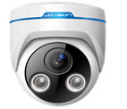  JVS-N63-HY | 1/4" OmniVision 1.0 Megapixel  CMOS Sensor OV9712S, HISILICON DSP Hi3518E  Main Stream: 720P@25fps; 12V DC/ 300mA  2 Megapixel HD Lens, with IR-CUT 4mm  IR LED: 2PCS Array Lights ,plastic case ext.audio in | port 9101  CLOUDSEE: PC,Android,Iphone  Jovision NVR system  NETIP , ONVIF | 45
JVS-N73-HY | 1/3" Aptina 1.3 Megapixel CMOS Sensor ARO130  HISILICON DSP Hi3518C  Main Stream: 960P@25fps;  2 Megapixel HD Lens, with IR-CUT 6mm  12V DC/ 300mA  IR LED: 2PCS Array Lights ,plastic case ext.audio in | port 9101  CLOUDSEE: PC,Android,Iphone  Jovision NVR system  NETIP , ONVIF | 70
JVS-N83-HY | 1/2.7" OmniVision 2.0 Megapixel CMOS Sensor OV2710  HISILICON DSP Hi3516C  Main Stream: 1080P@25fps;  3 Megapixel HD Lens, with IR-CUT 3.6mm, 6mm  12V DC/ 300mA ext.audio in / video/audio stream  IR LED: 2PCS Array Lights ,plastic case ext.audio in | port 9101  CLOUDSEE: PC,Android,Iphone  NETIP , ONVIF  Jovision NVR system | 90
JVS‐N5DL‐HC  POE | 1/2.7" OmniVision 2.0 Megapixel CMOS Sensor OV2710  HISILICON DSP Hi3516C  Main Stream: 1080P@25fps;  3 Megapixel HD Lens, with IR-CUT 2.8-12mm  POE- 802.3 AF/AT ext.audio in / video/audio stream  24 IR LED metal case  ext.audio in / video/audio stream | port 9101  CLOUDSEE: PC,Android,Iphone  NETIP , ONVIF  Jovision NVR system | 120
JVS‐N5DL‐HC  POE | 1/2.7" OmniVision 2.0 Megapixel CMOS Sensor OV2710  HISILICON DSP Hi3516C  Main Stream: 1080P@25fps;  3 Megapixel HD Lens, with IR-CUT 3,6 , 6 mm  POE- 802.3 AF/AT ext.audio in / video/audio stream  24 IR LED metal case  ext.audio in / video/audio stream | port 9101  CLOUDSEE: PC,Android,Iphone  NETIP , ONVIF  Jovision NVR system | 110
JVS‐N4DL‐HC  POE | 1/3" Aptina 1.3 Megapixel CMOS Sensor ARO130  HISILICON DSP Hi3518C  Main Stream: 960P@25fps;  2 Megapixel HD Lens, with IR-CUT 3.6mm  POE- 802.3 AF/AT  24 IR LED metal case  ext.audio in / video/audio stream | port 9101  CLOUDSEE: PC,Android,Iphone  NETIP , ONVIF  Jovision NVR system | 10085
JVS‐N4DL‐HG | 1/3" Aptina 1.3 Megapixel CMOS Sensor ARO130  HISILICON DSP Hi3518C  Main Stream: 960P@25fps;  2 Megapixel HD Lens, with IR-CUT 2.8 mm  12V DC/ 300mA  24 IR LED metal case ext.audio in | port 9101  CLOUDSEE: PC,Android,Iphone  NETIP , ONVIF  Jovision NVR system | 85
JVS-N81-HY -S  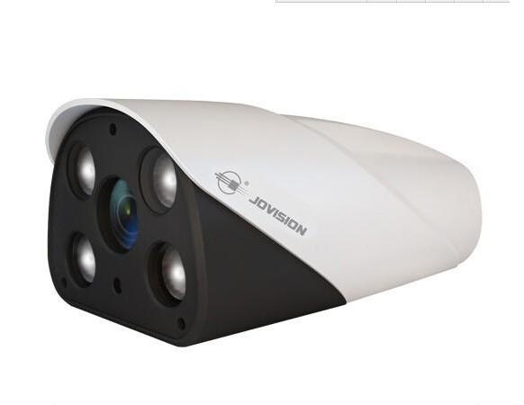  POE | 1/2.7" OmniVision 2.0 Megapixel CMOS Sensor OV2710  HISILICON DSP Hi3516C  Main Stream: 1080P@25fps;  3 Megapixel HD Lens, with IR-CUT 3,6 / 6  POE 802.3 AF/AT ,IR LED: 4PCS Array Lights  metal case, with bracket  ext.audio in / video/audio stream | port 9101  CLOUDSEE: PC,Android,Iphone  Jovision NVR system  NETIP , ONVIF | 135
JVS‐N71‐ZCP | 1.3MP IP Camera for Car Plate Recognition  1/3" Aptina 1.3 Megapixel CMOS Sensor ARO130  HISILICON DSP Hi3518C  Main Stream: 960P@25fps;  2 Megapixel HD Lens, with IR-CUT 8 mm  12V DC/ 300mA with White LED lamp | port 9101  CLOUDSEE: PC,Android,Iphone  Jovision NVR system  NETIP , ONVIF | 400
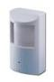  KDM-6716B | H.264 Dual stream encoding;1/3''AR0130 1.3 Megapixel CMOS, :1280*960@ 25fps,3.7/6mm pinehole lens;Support Multi-Screen software and CMS | ONVIF2.4  CMS3.0  port 34567  CMS3.0.9.xx  VmEye super,  XMEYE | 80
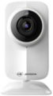  JVS-H210 | 1/4" CMOS,with 3.6mm lens 1Mp 720p  Hi3518E+OV9712S ★Built-in MIC & speaker and audio ★Day&Night with IR-CUT,10 pcs of Led ★AP&Soundwave Configuration  WiFi only !  SD card support - CIF | port 9101  CLOUDSEE: PC,Android,Iphone  Jovision NVR system  NETIP, ONVIF | 36

кабели и аксесоари
вид | разфасовка | единична цена лв с ДДС /брой, метър/
кабел RG174U , черен | 200m | 0.39
кабел комбиниран  / микрокоакс.+захранване / бял/чер | 100м, 200м | 0.80
кабел FTP 5E AWG24 Cu , сив , черен | 305м | 0.55
кабел FTP 5E AWG24 Cu / M , сив ,  с носещо въже | 305м | 0.75
кабел FTP 5E AWG24 Cu , черен, сертифициран / по-устойчив на външни условия/ | 305м | 0.65
кабел ШВПС 2х1.0 мм2 бял | 100м | 0.60
BNC конектор | 100 | 0.70
захр. букса 2.1мм женска | 1 | 0.50
разклонителна кутия -бяла, IP54  85x85mm , 100x100mm | 1 | 1.30
кутия ABS IP66 200x120x75 | 1 | 14
кутия ABS IP66 272x185x75 | 1 | 19
обективи CS , C - 2.8,4,6,8,12,16,25,35mm | 1 | 3
обективи CS DC drive 4/6/8/12/16/ 3-8 mm | 1 | 5

ЗАХРАНВАЩИ БЛОКОВЕ
номенклатура | описание | цена лв с ДДС
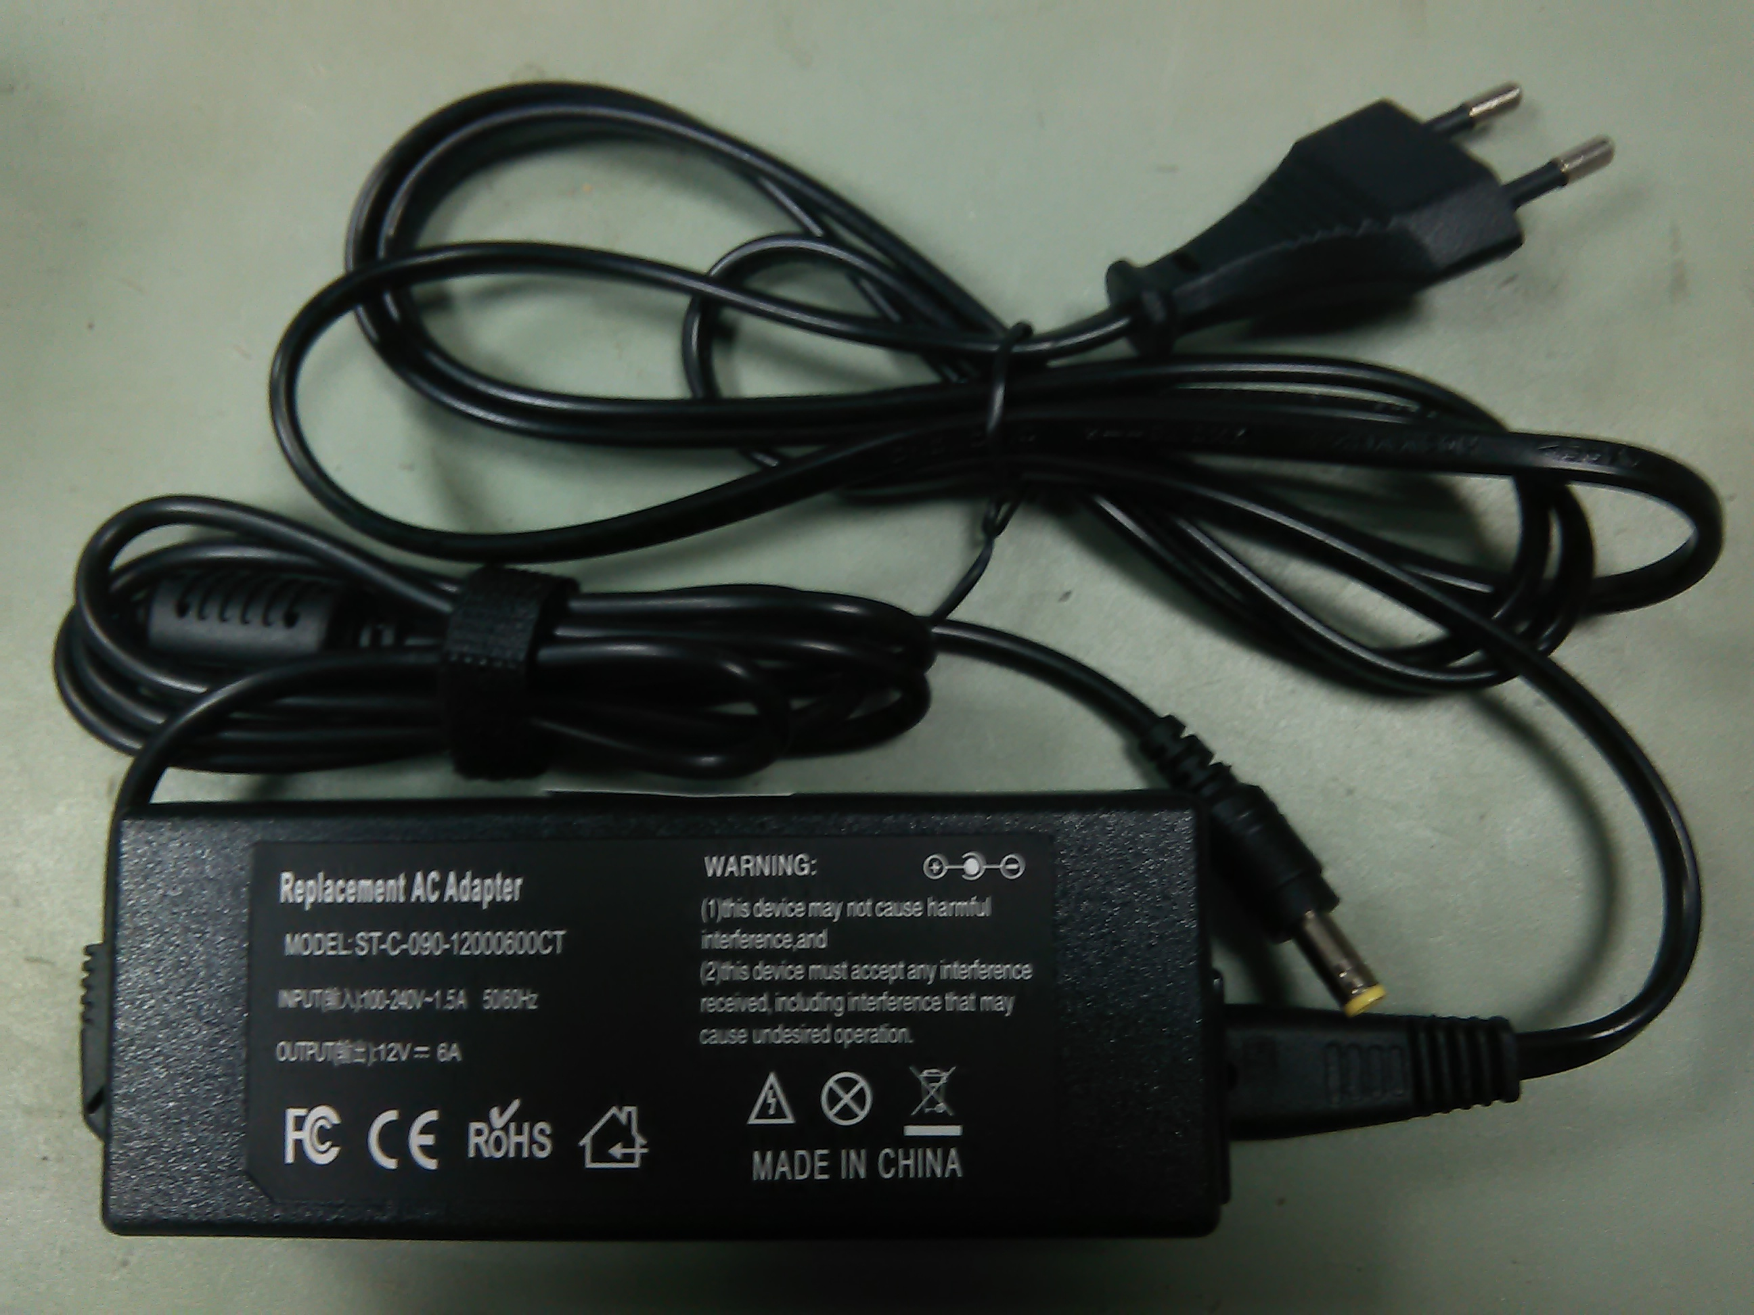  ST-C-090-12000600CT | захранващ блок 12V/6A  изолиран пластмасов корпус , с кабел 220V - двужилен | 36
S350-XX | S350-12 12V DC / 350W  S350-24 24V DC / 350W  S350-48 48V DC / 350W  http://www.smun.cc/en/Catalogue/350w%2048v%20power%20supply-104.html | 60  60  60
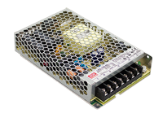  LRS150-48 Meanwell | http://meanwell.bg/files/M2016H1/LRS-150-SPEC.pdf  48VDC / 150W | 48
LRS100-12 Meanwell | 12VDC / 100W | 40
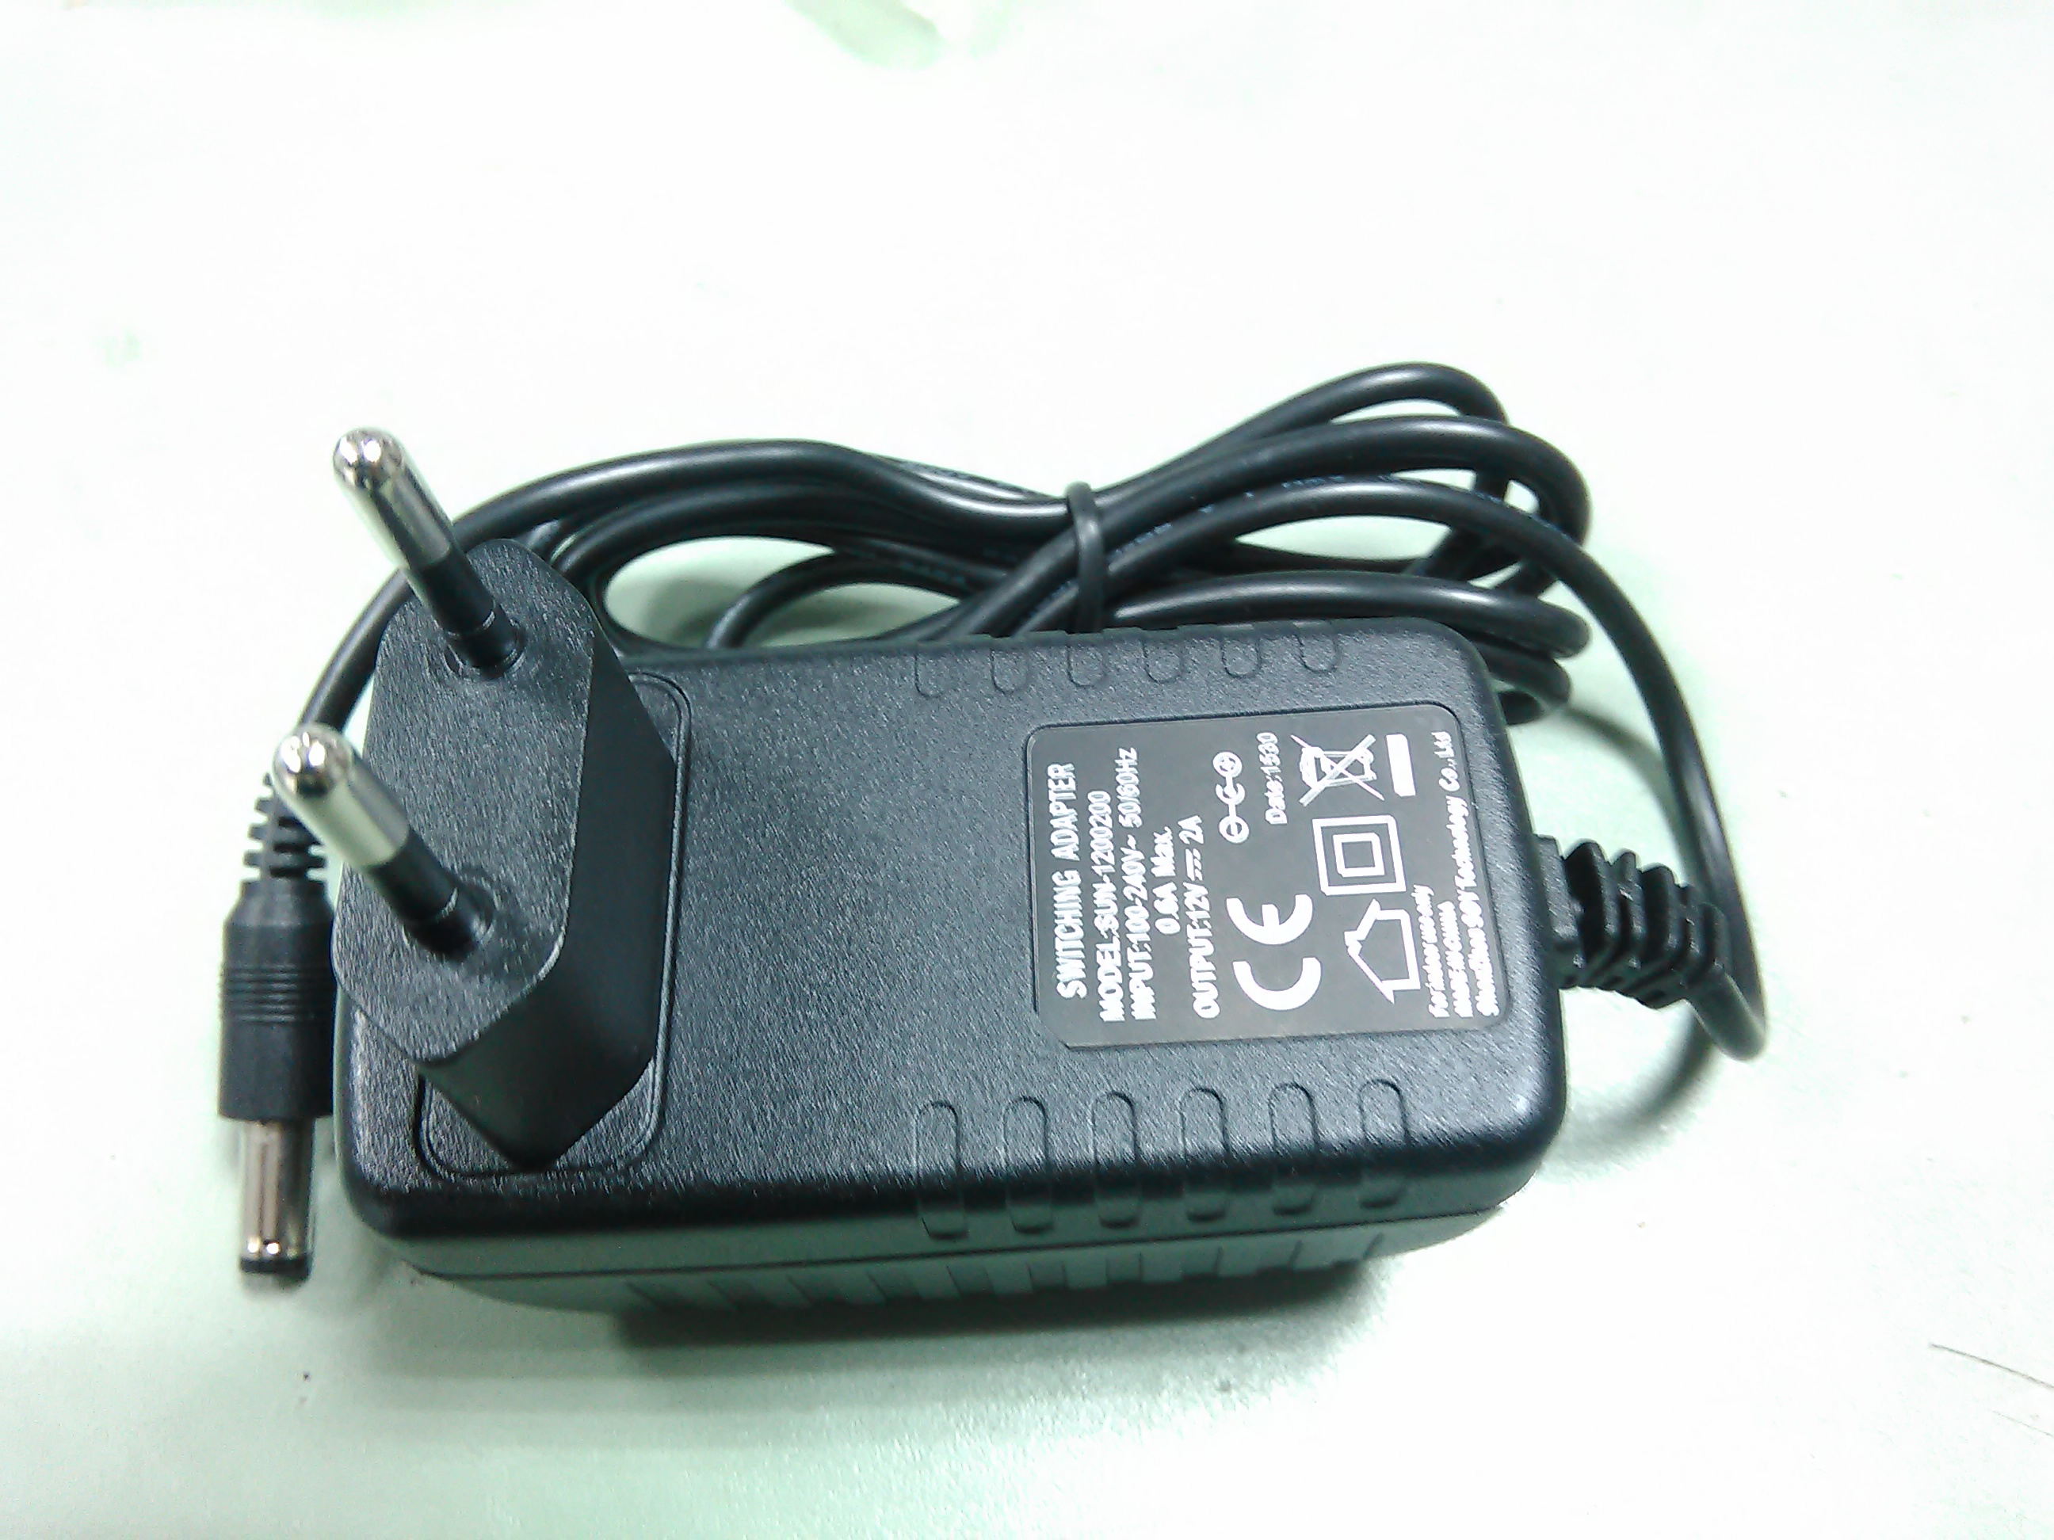 | адаптер 12V/2A | 15
DC-DC converter | 35-55V DC - 12 V DC 12W разделен галв.  30-60V DC - 12 V DC 30W разделеN | 12  36
AC-DC | трансформатор 70V DC / 80W , в метална кутия | 50

мрежови комутатори
номенклатура | описание | цена лв с ДДС
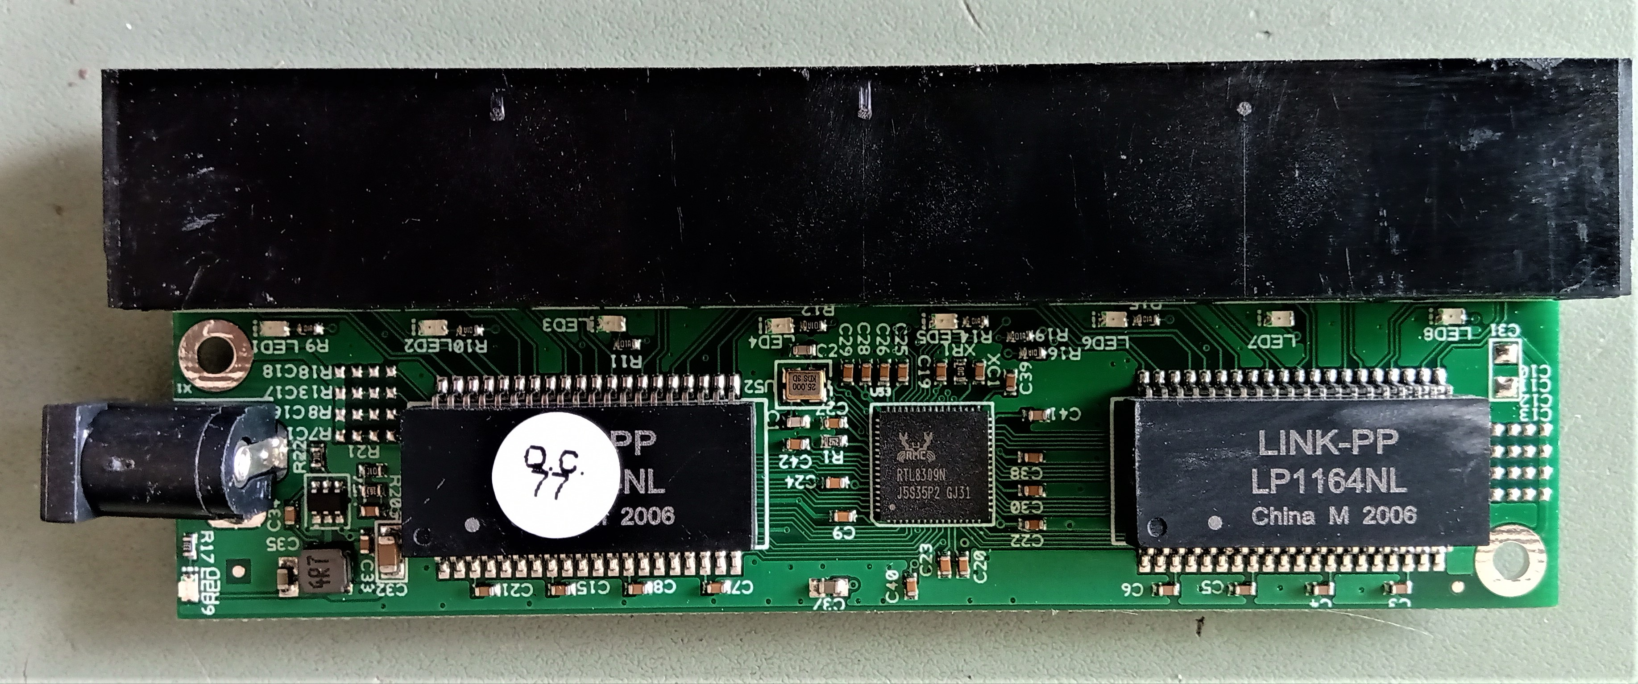  switch 8 port 10/100 | switch 8 port 10/100 RTL8398N  5V DC - 16 V DC  неуправляем | 20
DGS-1100-08 | D-Link DGS-1100-08, 8 портов 10/100/1000 Gigabit Smart Switch, управляем 5V DC | 72
DGS-1100-16 RACK | D-Link DGS-1100-16, 16 портов 10/100/1000 Gigabit Smart Switch, управляем . 220 V AC | 220
DGS-1210-24 RACK | D-Link DGS-1210-24, 24-портов 10/100/1000 Gigabit Smart Switch including 4 Combo 1000BaseT/SFP, управляем 220 V AC | 280
DGS-1210-28 RACK | D-Link DGS-1210-248 28-портов 10/100/1000 Gigabit Smart Switch including 4 Combo 1000BaseT/SFP, управляем 220 V AC | 330
GO-SW-16G RACK | D-LINK GO-SW-16G, 16 портов, Gigabit  неуправляем 12V DC | 110

