IE User manual

V1.1.1
CONTENT
1 Network Setup 5
1.1 Network Status 5
1.2 Ethernet Setup 8
1.3 WIFI Setup 8
1.4 ADSL Setup 9
1.5 DDNS Setup 9
1.6 UPNP Setup 10
1.7 FTP Account 10
1.8 SMTP Account Setup 11
1.9 Stream Setup 11
1.10 Platform Setup 12
2 Media Setup 13
2.1 Play Video 13
2.2 Video Capture 15
2.3 Privacy Mask setting 16
2.4 Time and Title Setup 17
2.5 Video Encode 17
2.6 Picture Capture 18
2.7 Audio Capture (the model R have not this setting) 19
2.8 Audio Encode (the model R have not this setting) 19
2.9 Media Status 19
3 PTZ Setup 20
3.1 PTZ Basic (the model R have not this setting) 20
3.2 PTZ Advanced (the model R have not this setting) 20
4 Record and Replay 22
4.1 Storage Info 22
4.2 Play Back 22
4.3 Record Setup 25
4.3.1 Basic Setup 25
4.3.2 Motion Detect Alarm Record 25
4.3.3 Motion Detect Alarm Capture 26
4.3.4 IO Alarm Record (the model R have not this setting) 26
4.3.5 IO Alarm Picture Capture (the model R have not this setting) 27
4.3.6 Schedule Record 27
4.4 Storage Manage 28
4.4.1 Un-mount 28
4.4.2 Format 29
5 Alarm Setup 30
5.1 Motion Detect Alarm Setup 30
5.2 IO Input Alarm (the model R have not this setting) 32
5.3 Video Lost Alarm 33
5.4 Storage Full Alarm 34
6 System Setup 35
6.1 Serial Number and Kernel Version 35
6.2 Account Manage 35
6.2.1 Add, Delete 35
6.2.2 User Group 36
6.3 Time Setup 37
6.4 Log Setup 37
6.5 Log View 38
6.6 Log File 39
6.7 Config Manage 40
6.8 Restore Config 40
6.9 System Update 40
6.10 Reboot 42
6.11 Language 42
7 Frequently Asked Questions 44
7.1 Why can not access the CAMERA by IE? 44
7.2 Why the PTZ can not control? 44
7.3 Why can not switch the data? 44
7.4 Why can not access the CAMERA after update? 44
7.5 No sound after click “Voice talk” 44

1 Network Setup

1.1 Network Status
The connection schematic diagram for the entire system frame of CAMERA is as figure 1.1. Connect PC and CAMERA directly and set network parameter as follow: 1.the default IP address is 192.168.0.123, net mask is 255.255.255.0, so you must add a IP address make the PC can access the device (such as 192.168.0.88). 2. The net mask of the PC and the CAMERA must be same. Make sure the direct network is through, as follow: “Start”-“Run”-enter “cmd” then enter “ping 192.168.0.123” and press “enter” on the keyboard. As figure 1.3, 1.4, and1.5. While the network is not through, please check it.
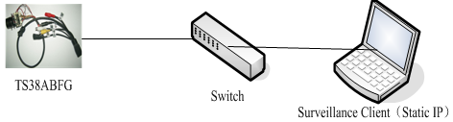
Figure1.1 connecting schematic diagram
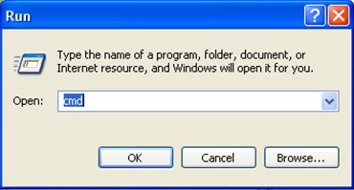
Figure1.2 enter “cmd”
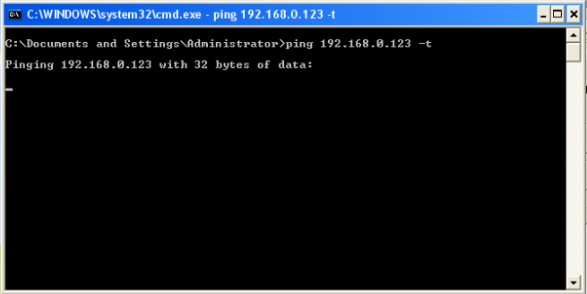
Fiure1.3 enter “ping 192.168.0.123 –t”
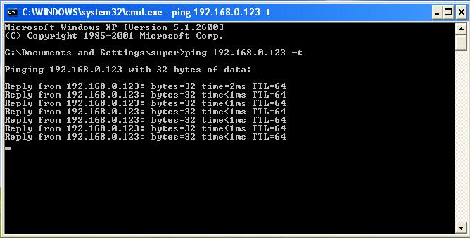
Figure1.4 network is through
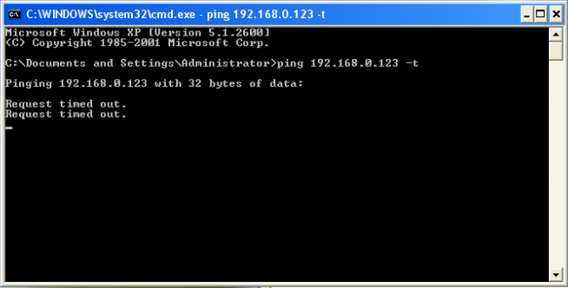
Figure 1.5 networks is not through
After then, power on. Enter the IP address in IE browser and press “enter”. Then it will display the following interface as figure1.6, and then enter user name (admin) and password (123456) and click “Login”.
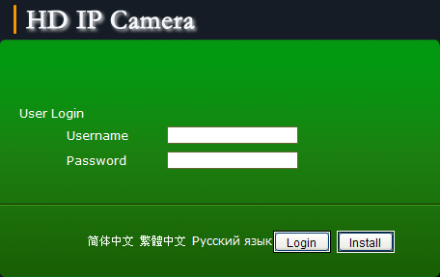
Figure 1.6 Login interface
After enter system select and click “Network Setup”, it will display interface as figure 1.7, displaying the IP address, gateway, net mask and DNS and so on. The detail information please refers to the actual configuration.
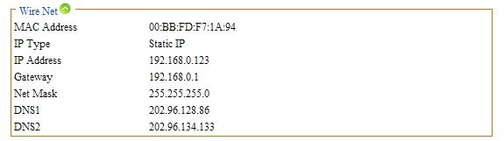
Figure 1.7 Network status

1.2 Ethernet Setup
Ethernet setup as figure 1.8, all the parameter in the interface is needed to be reset.
Also you can modify the IP address by IP search (carried with UC2) or other tools. Make sure the IP address to be modified and IP address of your PC are in the same network segment, and the IP address to be modified can not be the same as the IP address of the PC in the network segment. After reset IP address the device will reboot, then use the new IP address to access the CAMERA.
Net mask matches with IP address to distinguish network address and local address, usually set it as 255.255.255.0. The correct net mask is the premise for saving it.
Gate way is point between two networks such as router. So you can enter the router IP address.
DNS server address is host IP address running the domain server, which provide by network operators.
If enable the function of DHCP the device will obtain a dynamic IP address.
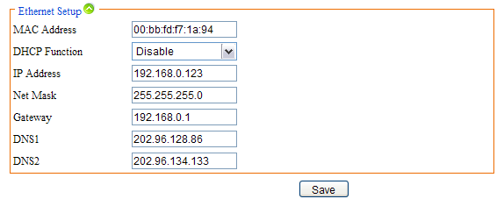
Figure 1.8 Ethernet setup

1.3 WIFI Setup
WIFI setup as figure 1.9
First you need to set wireless router called AP for short. All parameters in this interface must be the same with the router setting. This interface only display with WIFI firmware of CAMERA.
Note: only when the device updates a WIFI firmware and owns a WIFI module there will be WIFI setup.
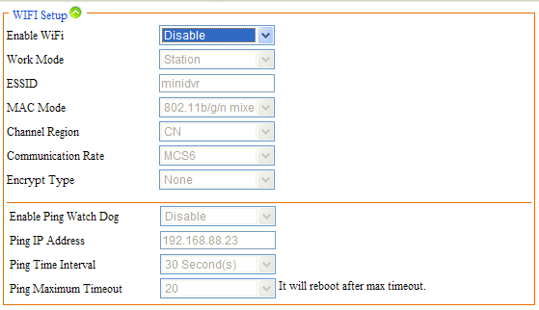
Figure 1.9 WIFI Setup

1.4 ADSL Setup
ADSL setup as figure 1.10
The username and password of the ADSL are provided by network operators, enter the correct username and password, enable ADSL and save it.
It can run correctly on premise that the username, password and the confirm password is correct.
It will prompt error while the password and confirm password is incorrect. In order to verify the ADSL is run correctly, you can enable DDNS and access the device by domain name. Enable DDNS as figure 1.11 DDNS Setup)
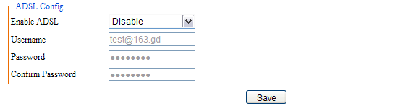
Figure 1.10 ADSL Setup

1.5 DDNS Setup
DDNS setup as figure 1.11
First you must have a domain name. www.3322.org is recommended; please remember the username, password and domain name.
Then enable DDNS, select the DDNS Server as “3322.org”. If your domain name is “test.3322.org”, please enter “test” in the DDNS Domain, and the User Name and Password is the username and password that applied in the www.3322.org. Set the Refresh Time as 1 minute, then DDNS will work after 1 minute.
Last you can access the device by domain name.
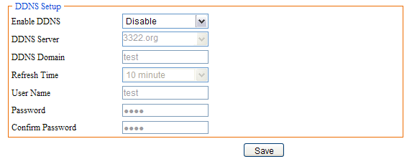
Figure 1.11 DDNS Setup

1.6 UPNP Setup
UPNP setup as Figure 1.12
UPNP run by external address and port.
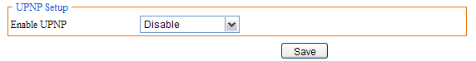
Figure1.12 UPNP Setup

1.7 FTP Account
FTP account setup as Figure1.13
First a FTP server is indeed. Then apply a FTP account from the FTP server (username and password). And you must create four directory as “alarm”, “log”, “set”, “update” or other directory name, also you can enter “./” then the entire document will be save in the root of the FTP server.
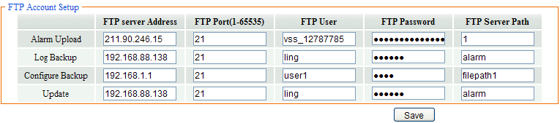
Figure1.13 FTP Setup
The default port of FTP is 21. The information of the interface must be correct to make sure the FTP function run correct.
Alarm upload, log backup, configure backup and update can be uploaded by FTP.

1.8 SMTP Account Setup
SMTP account setup as figure1.14
This function not only support internal mail transfer but also internet.
SMTP Server Address is refers the IP address of mail server, such as QQ is smtp.qq.com, NetEase,Inc is smtp.163.com.
SMTP Server Port usually set as the default port 25.
SSL/TLS connect is a mode to verity security. When SMTP server enables this function here must enable, otherwise the same.
Mail Account is a user or to say an address in SMTP servers. You must enter a correct account and the correct password.
Show Account is the same as Mail account.
User Mail Address is the mail address that you want to receive the mail. SMTP Server Address and User Mail Address, if former is internal the latter must internal, otherwise if former is internet the latter must internet too. CC Mail Address is means when the device set mail to User Mail Address, it will copy the mail and set to CC Mail Address. CC Mail Address has the same rule with User Mail Address.
Mail Subject is the subject of the mail, you can write it by yourself.
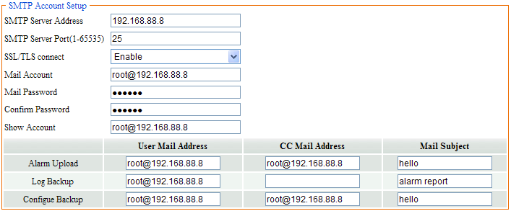
Figure1.14 SMTP Account Setup

1.9 Stream Setup
Stream Setup as figure 1.15
Access Protocol: while the device is in public network, TCP is a better choose, while the device and the user are the same network then UDP is a better choose.
The default WEB port is 80. You can change it at will. But if you change it as 8080, then you enter 192.168.0.123:8080 for accessing the device.
All the port in the interface can change at will but can not be the same or the used port such as 3000, 8888. When you do not want to set the port as default port them must bigger than 1000. Only when the three ports set legitimate value you can normally access the device.
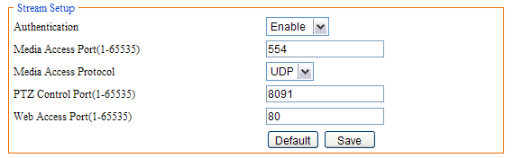
Figure1.15 Stream Setup

1.10 Platform Setup
Platform Setup as figure1.16
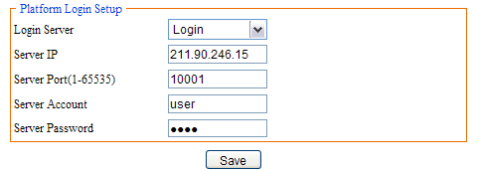
Figure1.16 Platform Setup
The device can login platform server on the premise that the server IP and Server port is corresponding to the server. The server account and password can enter them wt will. Of course enable login server is indeed.

2 Media Setup

2.1 Play Video
The window for playing video as 2.1, it includes video window and PTZ control.
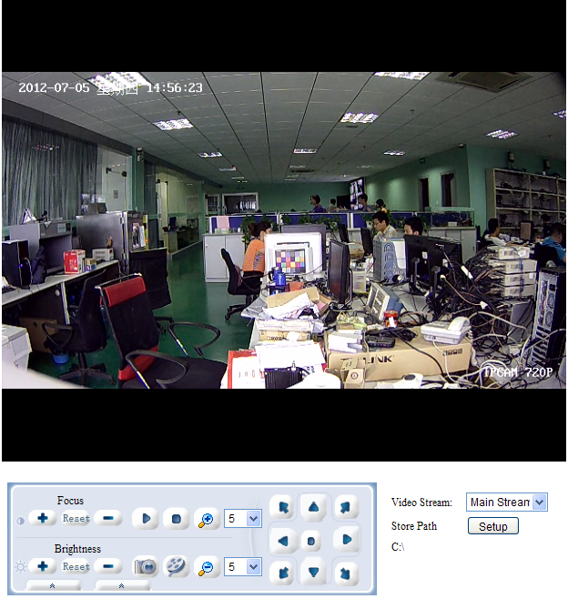
Figure2.1 Playing Video
Video window：Double click the real-time video then it will display video full-screen. Double click it again then it will recovery default window.
Video Stream: Select “Main Stream” or “Sub Stream” to play in the video window.
Store Path: click “Setup” for resetting the store path.
Focus+: Focus far
Focus-: Focus near
Focus Reset: Reset default focus.
Brightness+: Increase brightness
Brightness-: Reduce brightness
Brightness Reset: Reset default brightness
Play: Click the button, it will play video while the video stop
Stop: Click the button to stop real-time video
Capture: Click the button once, it will capture a picture
Record: Click the button to start to record, re-click the button to stop to record.
Zoom In/ Zoom Out: Zoom lens
Left- Right/Up-Down Speed: The PTZ speed of rotation range from 0 to 10
Direction: Click the 9 buttons to control the PTZ
Click in the left, it will pop a new interface as figure2.2:
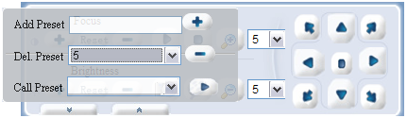
Figure 2.2 Preset
You can add/delete/call preset in the interface, steps as follow:
Add Preset: the preset number range from 1 to 255, first turn lens and enter preset number then turn lens again and enter preset number as so on.
Note: it will not save the preset number greater than 65
Del. Preset: Select a preset number to be deleted from the option box and click “Del. preset” bottom
Call Preset: Select a preset number from the option box and click “Call preset” then the lens will turn automatically.
Click in the right, it will pop a new interface as figure2.3:
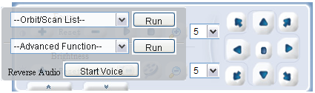
Figure2.3 Advanced function
Detail as follow:
Scan Begin: Turn lens and select “Scan Begin” in the “Orbit/Scan List” and click “Run”, then the direction is a “Scan Begin”
Scan End: Turn lens again and select “Scan End” in the “Orbit/Scan List” and click “Run”, then the direction is a “Scan End”
Scan On: When the “Scan Begin” and “Scan End” is done, then select “Scan On” in the “Orbit/Scan List”, and then the lens will turn between “Scan Begin” and “Scan End”
Scan Off: While the “Scan On” is running, select “Scan Off” to stop “Scan On”
Orbit: Select “Orbit” and click “Run” then the lens will turn among all preset number.
Orbit Stop: Select “Orbit Stop” and click “Run” to stop orbit.
Advanced Function: Includes “Black/White”, ”Color”, ”Mirror Off/On”, “Freeze Off/On”, “Steps Off /On”, “Screen Off/On”, “Lumen Off/On”, “ILL Off/On”, “Camera Reset/Switch”, “B/W Auto”, “WB R/G/B/M”, “Initial Set”, “Menu”, “Track Off/On”, “Path On/Off”, for example for “Black/White” and “Color”: we can see the preset number of “Black/White” and “Color” is 64, but “Black/White” is “Set preset” and “Color” is “Call preset”. The work of the advanced function is “set preset” and “call preset”. So select “Black/White”, it will play in black/white mode, while select “Color” it will play in color mode. All the function are same with them, but different camera with difference, please refer to the corresponding user manual of camera.

2.2 Video Capture
Video Capture includes two sides: IRCUT setting and video Capture Setup.
IRCUT has four work modes: active mode, day and night, passive, manual. The working principle of active mode is that it use module to set control signal to control light board, according light intensity auto switch color and black/white mode; day and night mode is by setting night start time and night end time, after enabled, during the time video always in black/white mode; passive mode use level control signal that send from light board to control the switch of module IRCUT; manual mode is to switch day or night mode manual. The function of “Keep color” means even if in black/night mode the video also colorful. “Sensitivity” is only function in active mode.
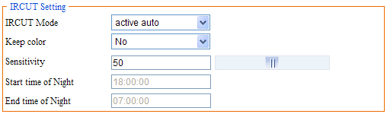
Figure 2.4 IRCUT setting
Video capture setup include “Brightness”, “Saturation”, “Sharpness” , “Contrast”, “Backlight Control” and so on , different country with different “Video Format”, in China just PAL format.
You can enter number manually or drag the slider; also click “default” is a good method. High “Saturation” means color is more obvious; High “Contrast” means the effect is more obvious. All the parameters must according to the physical environment.
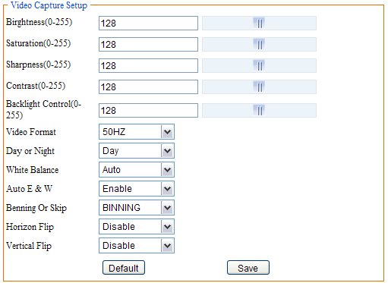
Figure 2.5 Video Capture Setup

2.3 Privacy Mask setting
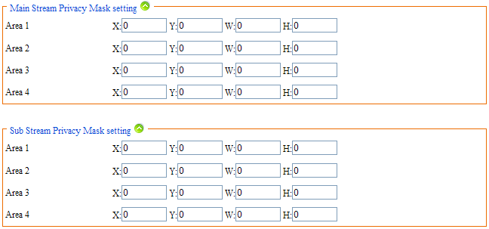
Figure 2.6 privacy mask setting
If you hope that some areas in the video to be hided you can set privacy mask area. You can respectively configure four privacy mask areas for main stream and sub stream. Every privacy mask area is determined by four coordinate values. The area being privacy areas will be black screen whether in real-time stream or in record.

2.4 Time and Title Setup
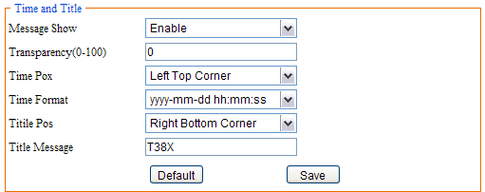
Figure2.7 Time and Title
As we know, time and title are displayed in the video window. But you can hide them or set their transparency, position and so on.
Transparency ranges from 0 to 100. 0 means the time and title is visible but 100 are not. (The parameter is reserved, do not work)
There are 8 time format, you can choose under preference.
There are 4 time/title positions, time and title display position to be in a different horizontal position.
The max length of the title message is 31 byte. Do not forget to save it!

2.5 Video Encode
Video encode includes two sides: Video Encode Parameter Setup and Video Encode Advanced Parameter Setup.
Video has two streams, one is main stream another is sub stream, the encode format of both are H.264.
Main stream of Camera only has one resolution 720P. Sub stream has ten resolutions to set.
To get better video in different network bandwidth environment, we use bit rate control method. When the information of the video increase imminently but the bandwidth is limited, you can choose variable bit rate (called VBR for short) to ensure the quietly of video. When the network bandwidth is stable, you can choose constants bit rate (called CBR for short). The third method is called CVBR, it give priority to CBR and compatible with VBR. So you should choose control method according to the network environment.
I frame is the key frame in video encode. In a bad network bandwidth environment, if I frame interval is too big, the quality of the video will be poor, even can not receive real video. In a good environment, there is no limit to set it. A good setting you can get by previewing the setting effect.
High frame rate means more fluent video. Low frame rate may cause picture update slow and bad interactive sense, so the suggestion setting is higher than 20.
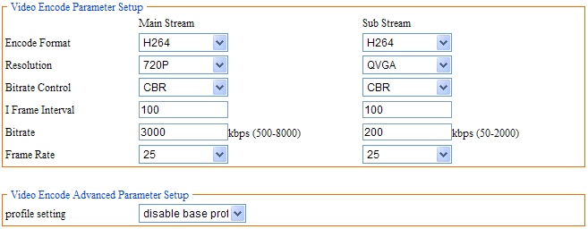
Figure2.8 Video Encode
Bit rate related to the speed of network transmission, that is to say how many kb information it could transfer every second. Because the resolution of main stream is times than sub stream, the date information need transferred in per second more, so need bigger bit rate. When the resolution is 1080P, the “Bit rate” at least 6000 kbps and when the resolution is QVGA, the “Bit rate” at least 300 kbps. The bit rate is too small result in poor image. Do not forget to save it!
In Video Encode Advanced Parameter Setup there is only one setting, “profile setting” is to set the device access to embedded NVR or not. When device need to access embedded NVR, must set it to “enable base profile encode” and please update the dedicated firmware.
User could click the button of “default” to set all parameter as default value, only after click “save” you can save your setting.

2.6 Picture Capture
In the interface, “Picture Source”, “Picture Quality” and “Capture Speed” need to be set. Of course, the default parameter is another way.
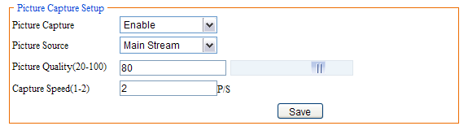
Figure2.9 Picture Capture
Picture source include “Main Stream” and “Sub Stream”; Picture quality range from 20 to 100, you also can drag the slider; Capture speed between 1 and 2, means 1 or 2 pictures per second.

2.7 Audio Capture (the model R have not this setting)
Only audio volume related to audio capture. Volume range from 1 to 100, you can enter number manually or drag the slider. Do not forget to save it!
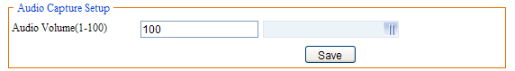
Figure2.10 Audio Capture

2.8 Audio Encode (the model R have not this setting)
Audio Encode is to set enable audio encode, encode type, sample rate, bit rate. Only when you has enable audio encode you can capture audio and you can hear from device.
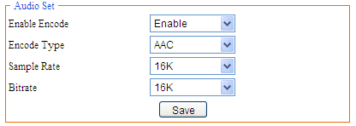
Figure2.11 Audio Encode

2.9 Media Status
In this interface, the main duty is display the status of video encodes.
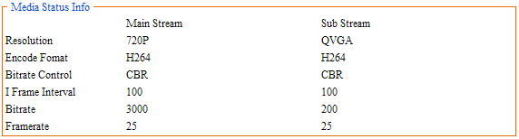
Figure2.12 Media Status

3 PTZ Setup

3.1 PTZ Basic (the model R have not this setting)
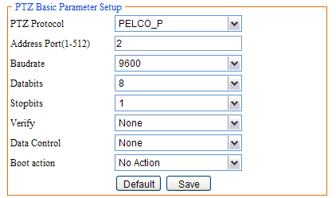
Figure3.1 PTZ Basic Parameter Setup
There are 8 parameters about PTZ basic setup, for example “PTZ Protocol”, “Address Port”, “Baud rate”, “Data bits”, “Stop bits”, “Verify”, “Data Control”, “Boot action”, as following figure:
The difference between PELCO-D and PELCO-P is different baud rate. All the parameter must be the same with the setup of corresponding camera. You can refer to the camera user manual.

3.2 PTZ Advanced (the model R have not this setting)
All the parameter about PTZ advanced as figure 3.2. The detail information refers to the user manual of camera.
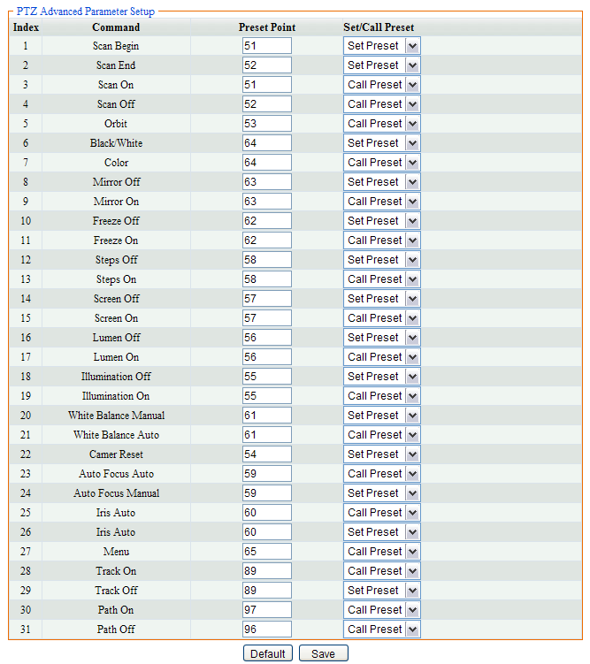
Figure3.2 PTZ Advanced

4 Record and Replay

4.1 Storage Info
In this interface, just only show the statue of the storage, as figure 4.1
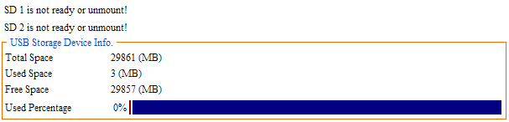
Figure4.1 Storage Information

4.2 Play Back
First you can set the query conditions about querying record as figure 4.2. Be careful, “End Time” can not more 7 days than “Start Time”. Record type include schedule, motion detect, alarm and all type; Media type include audio & video, video and picture; video stream include main stream, sub stream and all stream.
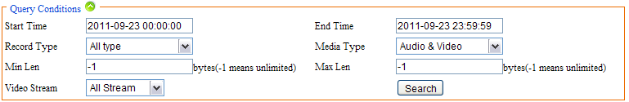
Figure4.2 Query Condition
Then click “Search”, the file will display in list as figure 4.3. The file name is the record time.
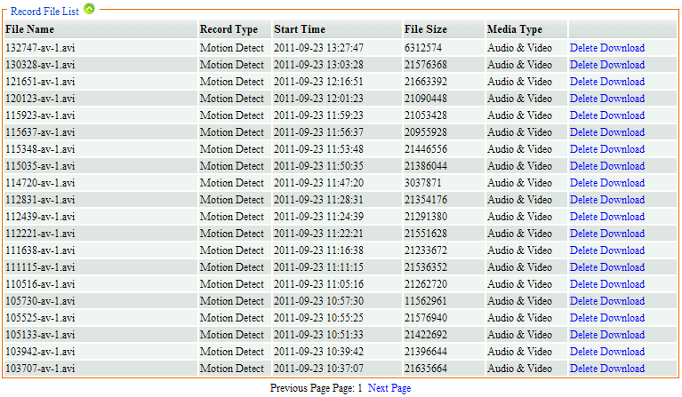
Figure4.3 Record File List
Last, you can play or delete or download the files. Click “Download” behind the selected record to play. As figure 4.4
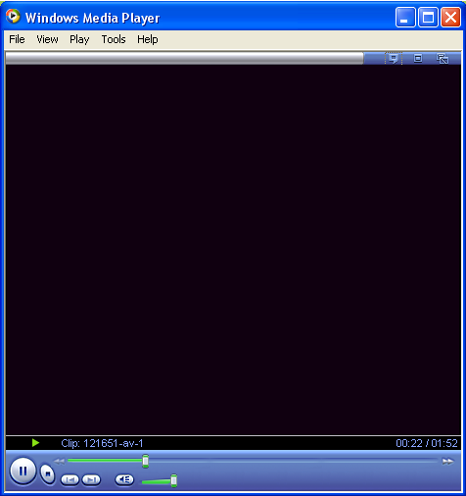
Figure4.4 Play record
Click “Delete” behind the selected record to delete. As figure 4.5
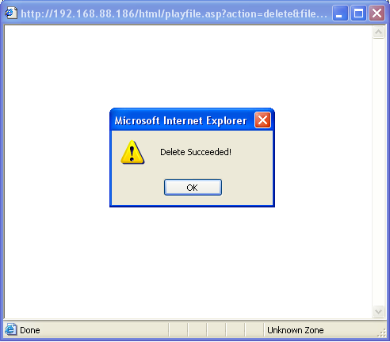
Figure4.5 Delete record succeeded
First right click “Download” for download the selected record then it will prompt a dialog figure 4.6, select a directory and change a name for the record, last click “Save”, well the record save succeeded.
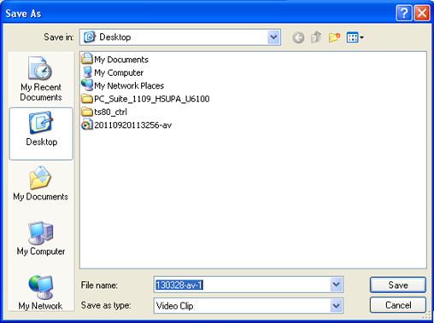
Figure4.6 Dialog

4.3 Record Setup

4.3.1 Basic Setup
In this option, you need to set 4 parameters “Local Storage”, “Storage Media”, “Storage Strategy” and “Max Time Each File”. There are 7 methods about storage media. Storage strategy includes “Overwrite When Full” and “Stop When Full”. “Overwrite When Full” means when all the storage is full, it will delete the old record and go on recording; “Stop When Full” means when all the storage is full, it will stop to record. The max time of each file is 10 or 20 or 30 minutes. But in fact the max time of each file is 10 minutes, so “Max Time Each File” does not work there.
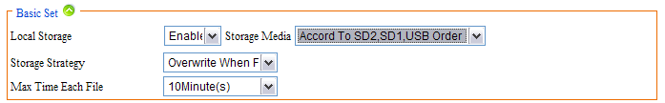
Figure4.7 Basic Set

4.3.2 Motion Detect Alarm Record
Motion Detect alarm record means it will start recording when motion alarm is coming.
Video stream include “Video Main Stream” and “Video Sub Steam”. The former means record with main stream; the latter means record with sub stream. Media type includes “Audio and Video” which means record with audio and video and “Video” which means record without audio. Prerecord time means it will prerecord when motion alarm is coming, the max time is 5 seconds and the min time is 1 seconds. The record time ranges from 10 to 600 seconds. Also you can set the motion alarm record upload to FTP or send a email to you. Do not forget to save it!
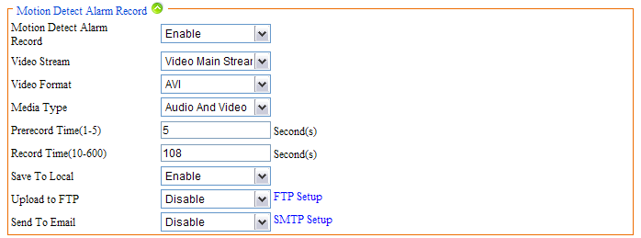
Figure4.8 Motion Detect Alarm Record
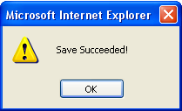
Figure4.9 Save

4.3.3 Motion Detect Alarm Capture
Another way for “Motion Detect” alarm is capture. Except pre-capture and capture time, the other parameter are the same with the parameter of “Motion detect alarm record”. “Pre-capture” is the same meaning with” Pre-record”, “Capture time” means the time of capturing.
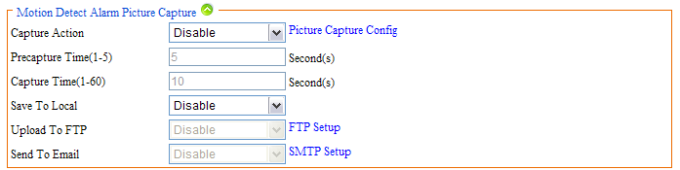
Figure4.10 Motion Detect Alarm Picture Capture
Before enable “Motion Detect Alarm Capture”, you must ensure “Picture Capture Setup” enabled.
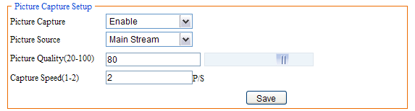
Figure4.11 Picture Capture Setup

4.3.4 IO Alarm Record (the model R have not this setting)
The setup method is the same with “Motion Detect Alarm Record”. The condition of alarm is not the same with “Motion detect alarm”, it will alarm when the IO is changing.
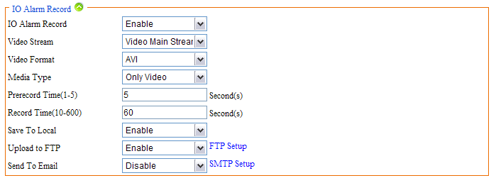
Figure4.12 IO Alarm Record

4.3.5 IO Alarm Picture Capture (the model R have not this setting)
The configure method is the same with “Motion Detect Alarm Capture”.
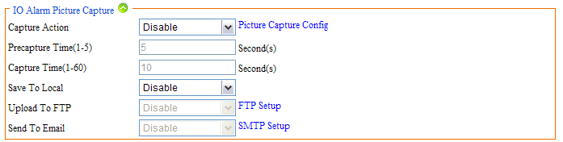
Figure4.13 IO Alarm Picture Capture

4.3.6 Schedule Record
Except “Video Stream” the other parameter is the same with “Motion Detect Alarm Record”, Video Stream include “Snapshot” which means it will take photo during the schedule record time, “Video Main Stream” and “Video Sub Stream”.
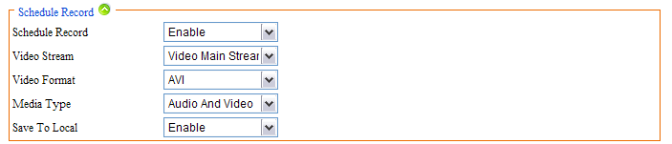
Figure4.14 Schedule Record
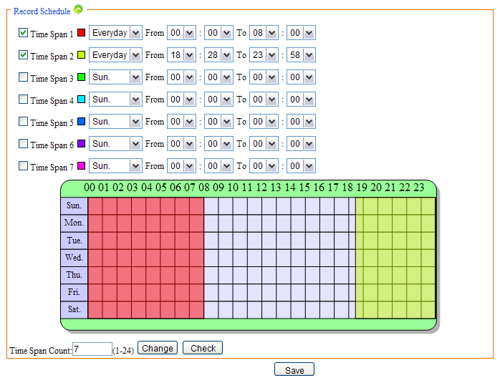
Figure4.15 Time Table
You can set time span for schedule record. The max number of time span is 24. And the time for schedule record and motion detect alarm record can not be the same.

4.4 Storage Manage

4.4.1 Un-mount
“Un-mount” means remove the storage from the device with a safe way, in order to prevent data been destruct. When click “Un-mount” it will pop-up a dialog as figure 4.17 and click “OK”, it will remove the storage. It prompt a dialog as figure 4.18 means remove successfully.
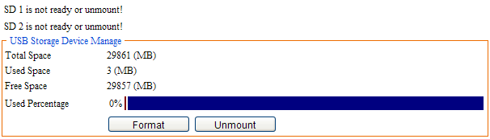
Figure4.16 Un-mount
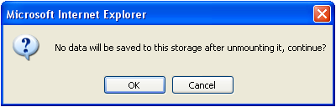
Figure4.17
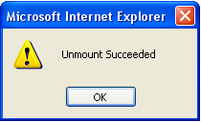
Figure4.18 Un-mount

4.4.2 Format
Select the storage to be formatted and click “Format” button, then it will prompt two dialogs figure 4.19, click “OK” to format or click “Cancel” to cancel it.
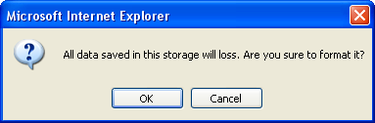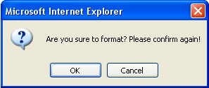
Figure4.19 Format

5 Alarm Setup

5.1 Motion Detect Alarm Setup
In this interface too many parameters need to be set, such as sensitivity, threshold, block count (checking area), night time span, night sensitivity, night alarm threshold and so on.
Sensitivity range from 1 to 100, 1 is the most insensitive; 100 is the most insensitive. Alarm threshold also range from 1 to 100, 1 is most likely to alarm; 100 is least likely to alarm.
As figure 5.1 we know, alarm is enabled, sensitivity is 100; alarm threshold is 10. Night time is also enabled, time span from 0:00 to 24:00.
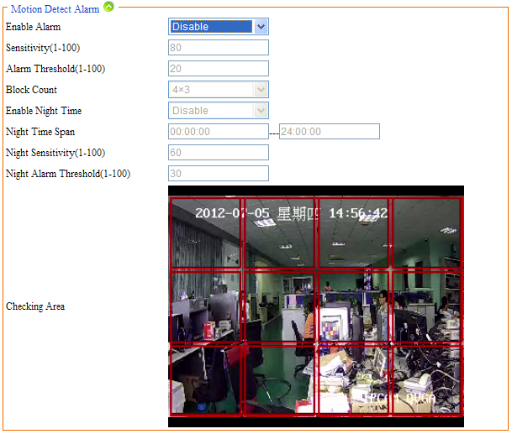
Figure5.1 Motion Detect Alarm
Also you can set alarm time as following. The max number of time span is 24. And the time for schedule record and motion detect alarm record can not be the same. Different time spans in different colors.
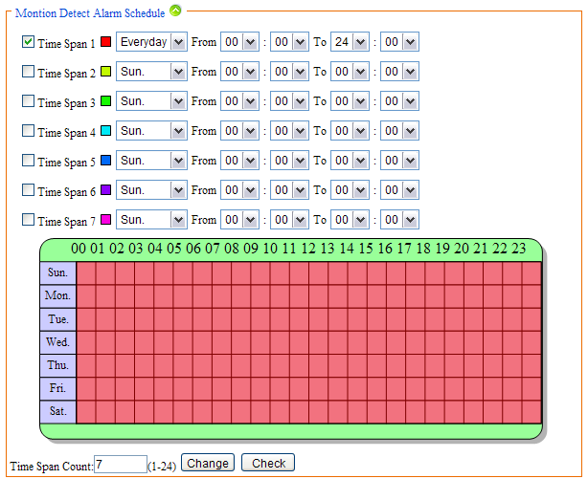
Figure5.2 Motion Detect Alarm Time
Each time span can not conflict, otherwise it will prompt figure 5.3:
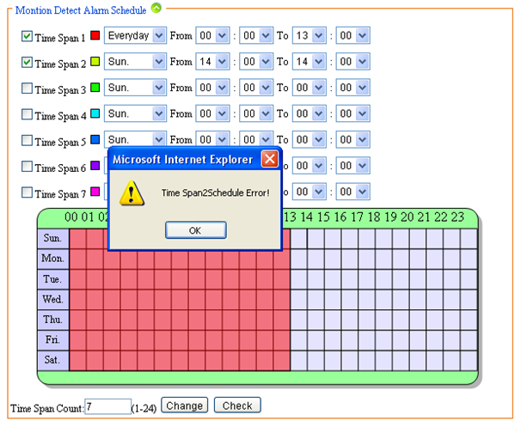
Figure5.3 Time Span Error
Alarm output is another way for alarm. Enable “alarm output” and connect external device for output such as speaker flash lamp. Alarm duration means during the time you set, it will go on alarm.
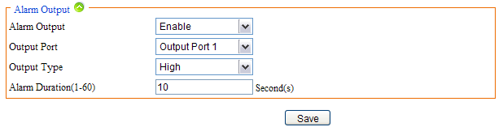
Figure5.4 Alarm Output

5.2 IO Input Alarm (the model R have not this setting)
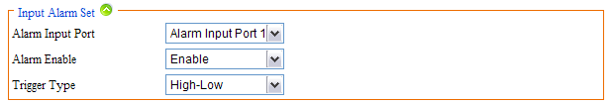
Figure5.5 IO Input Alarm
IO input alarm is triggered by IO interface. Enable it in the interface and connect external device for inputting.
Also you can set alarm time as following. The max number of time span is 24. Different time span shows in different color.
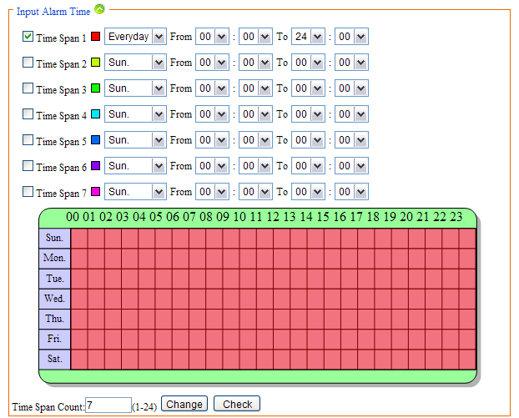
Figure5.6 Time Span
Alarm output is another way for IO alarm. Enable “alarm output” and connect external device for output such as flash lamp. Alarm duration means during the time you set, it will go on alarm.
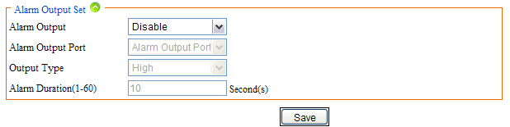
Figure5.7 Alarm Output Set

5.3 Video Lost Alarm
Too many reasons can cause video lost, such as disconnect video cable. In this case, we can enable “Video Lost alarm” for reminding. At the same time, many parameters need to be configured, as figure 5.8. Alarm output is another way for reminding “Video lost”. But you need to enable it and configure parameters for it.
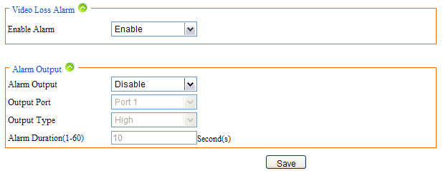
Figure5.8 Video Lost

5.4 Storage Full Alarm
If the storage with CAMERA then you can enable “Storage Full Alarm”, it will alarm when the usage of the storage close to 100%. In this page, alarm rate is usage of storage such as 95, it means it will alarm when the usage is 95%. Alarm output is similar to the other alarm output before.
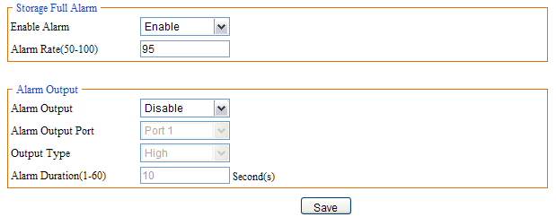
Figure5.9 Storage Full Alarm

6 System Setup

6.1 Serial Number and Kernel Version
In this page you can view kernel version, serial number, file system version and web page version. As figure 6.1
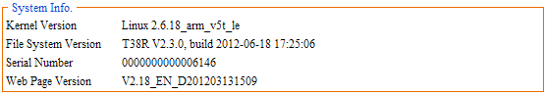
Figure6.1 System Info

6.2 Account Manage

6.2.1 Add, Delete
Add and delete user for accessing the CAMERA in this page. The username can’t be empty, only letter and number are allowed. The length of username is 30 bytes.
The most number of users are 10. The entire users will display in the “All Accounts” table.
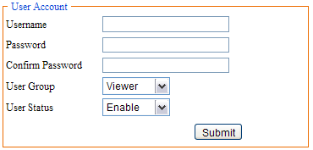
Figure6.2 Add User
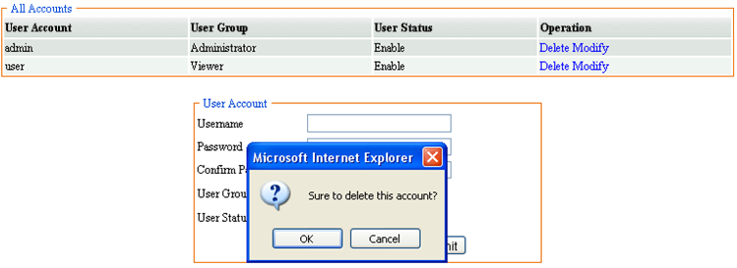
Select the user to be deleted, and click “Delete”, and it will pop-up a dialog, click “OK”, then the user was deleted figure 6.3, 6.4.
Figure6.3 Delete user
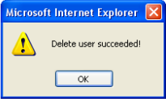
Figure6.4 Delete user succeeded

6.2.2 User Group
Different user can have different permissions. Click “Modify” to modify the user or disable it or modify password.
There are three different types of user group, viewer, operator and administrator. As a viewer, you only can view network status, media setup, storage info, serial number and so on. As an operator, you only can operate but can’t mange. Of course, administrator can do anything.
If you want to modify a user as an operator, first you need to select it and click “modify”, then it will display in “User Account” table, last you need to select “Operator” in “User Group” as figure 6.5 and click “Submit”. It will prompt “Modify user succeeded” figure6.6.
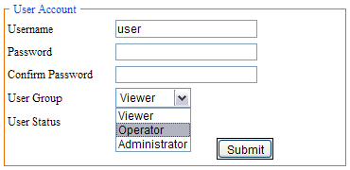
Figure6.5 Modify User
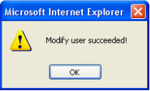
Figure6.6 Modify Succeeded

6.3 Time Setup
There are two type of update mode in this system. One is “Manual”, the other is “NTP Server”.
“NTP Server” will choose a same time zone with the client automatically. NTP IP is “time.windows.com”. NTP port can be a valid port and “Refresh Time” can range form 60 to 999999. Save all parameter, then it will update as a network clock.
“Manual” means update time manually. You need to enter time, time zone and date manually.
It will reboot after re-set time
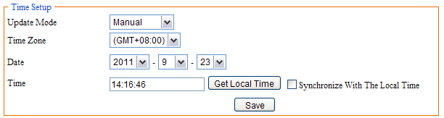
Figure6.7 Manual
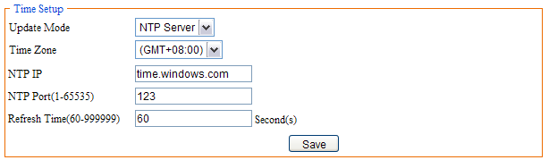
Figure6.8 MTP Server

6.4 Log Setup
In this page, you can set “output log type” according to actual needs. There are many types such as “Debug”, “Run”, “Error”, “Operation”, “Alarm”, “Statistic” and “Common”. Saving days range from 7-30 days. Store strategy includes “Overwrite When Full” and “Stop When Full” which is the same with “Storage Strategy” of record basic setup. Also you can backup the logs by two methods, one is “Update to Email”, and the other is “Update to FTP”. But first you need to enable “Auto Backup”.
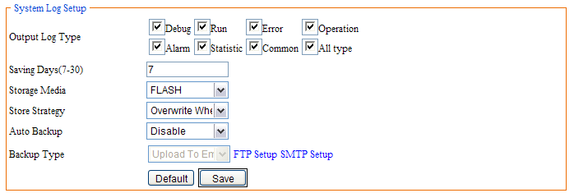
Figure6.9 System Log Setup
Figure6.10 Save Succeeded

6.5 Log View
This page, you can view the all logs that have been saved. First set “Log Date” that you want to view the logs and “Log Type”, click “Search”. Then it will list in the “System Log” table.
Search condition figure 6.11:
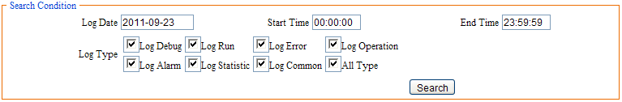
Figure6.11 Search Condition
System log figure 6.12:
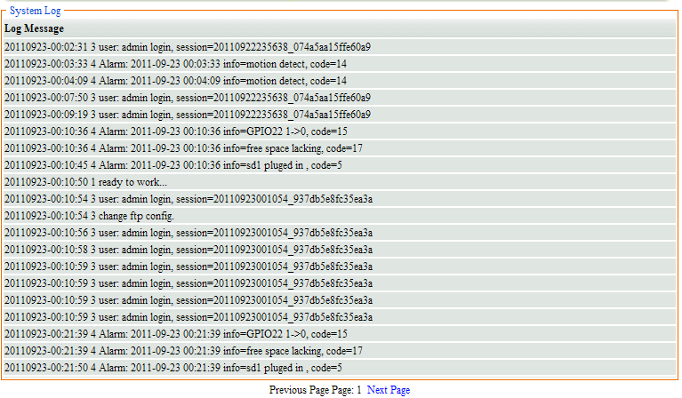
Figure6.12 Log View

6.6 Log File
There you can download or delete logs. Set “search condition” and click “Search”, it will display log by day figure 6.14.
Figure6.13 Search Condition
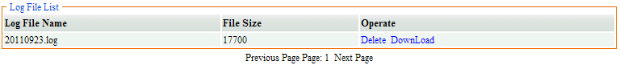
Figure6.14 Log File List
In the “Log File List”, you can download or delete log. Click “download” then it will download the log. Click “Delete” then it will delete the log. It will prompt “Delete Succeeded” after delete the log figure 6.15.
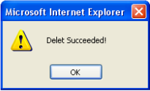
Figure6.15 Delete Succeeded

6.7 Config Manage
When all parameters have been modified, you can download the configuration file and save it. Then you do not need to modify again only upload configuration file. Also you can view the configuration file in this page.
Before upload configuration file, you must have a configure file first, and then click “Browse” to find the configuration file, last click “Upload”, it will upload configuration file and reboot automatically.
The configure file can be backup to Internet as figure 6.17. First set FTP or SMTP and select “Backup to mail” or “Backup to FTP”, and then click “Backup”, you can query the configuration file by FTP or Email.
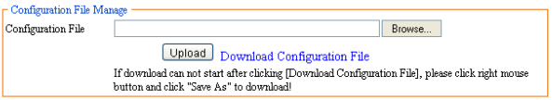
Figure6.16 Upload and Download
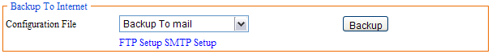
Figure6.17 Backup to Internet

6.8 Restore Config
“Restore Config” means restore factory settings. All the parameters set by you will be last. There will be confirming figure 6.18, click “OK”. All the parameters restore to default configure and reboot automatically
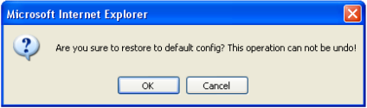
Figure6.18 Restore Config

6.9 System Update
When the software needs to be update, you can update firmware which would be provided by device suppliers.
Click “Browse” to select the correct firmware (figure 6.20) and click “Update”, it will prompt a dialog (figure 6.21), then click “OK”. After a while, it will prompt update succeeded ad figure 6.22, click “OK”, it will reboot automatically. If it update failed, it also will prompt a dialog to tell you update failed.
Note: the device can not be power off when updating. And the firmware must be correct.
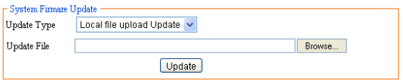
Figure6.19 System Firmware Update
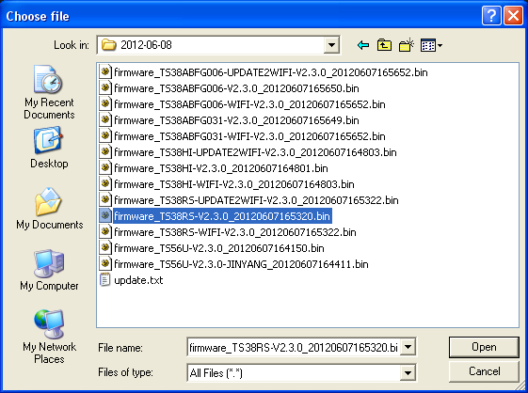
Figure6.20 Select firmware
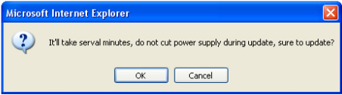
Figure6.21 Confirm Update
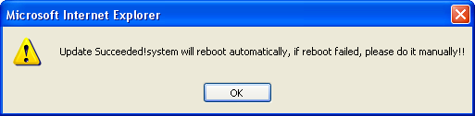
Figure6.22 Update Succeeded
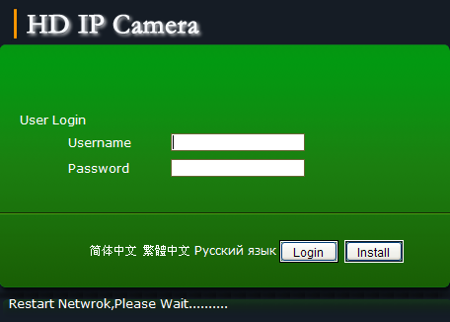
Figure6.23 Reboot

6.10 Reboot
When you want to reboot the device, then you can click “Reboot”. It will save all parameters and configuration. And it also will prompt a dialog to confirm. The restart time is about 75 seconds. Click “Cancel” to cancel reboot.
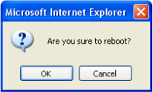
Figure6.24 reboot

6.11 Language
This version supports four languages: Simplified Chinese, Traditional Chinese, English and Russian. Select the language you need, click the button of “save”, then set language successfully. After that, system will auto jump to login-interface. When you access this device again, the login-interface is the language here you set.

7 Frequently Asked Questions

7.1 Why can not access the CAMERA by IE?
There maybe 4 reasons: NO.1, the network unreasonable. First you can connect network by PC, check the network cable is good. And check the network between the CAMERA and the PC is good as figure 1.3. NO.2, the IP address of the CAMERA is occupied by other device or PC. You can connect the CAMERA with your PC directly, and modify the IP address. NO.3, the CAMERA may be in other network. Check the IP address and net mask. NO.4 unknown: You can restore the CAMERA to default configuration.

7.2 Why the PTZ can not control?
Two reasons: NO.1 the PTZ protocol or address port or baud rate is incorrect, and then you need to modify the parameter according to the actual application as figure 3.1. NO.2 the PTZ cable is disconnected, and then you need to re-connect the cables.

7.3 Why can not switch the data?
Possible cause:
NO.1 Two-Switches: Whether the IP address is correct or not?
NO.2 Three-Switches: Whether port and physical address bindings?
NO.3 Firewall: First you can try to connect the CAMERA as figure 1.3. If the network timeout, you need to check the port mapping or re-set the firewall.

7.4 Why can not access the CAMERA after update?
Clean browser cache. Steps: open IE, click “Tools” and select “Internet Options”, then you can see “Temporary Internet files” and click “Delete Files”, it will prompt a dialog you need to check “Delete all offline content” and click “OK”. Also you can click “Start” and select “Run” then enter “cmd”, enter “arp -d” in “Command Prompt” interface. Re-access the CAMERA.

7.5 No sound after click “Voice talk”
First confirm the “Voice talk” start succeeded. Then check the CAMERA connect audio input device. Last check the wheat and headphones is good.

