Welcome to use our IPC product.
Following is quick manual for IE.
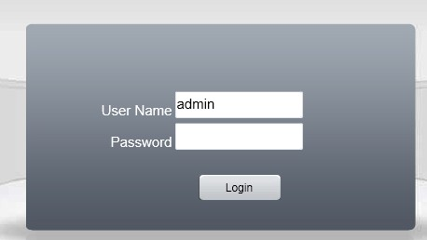
Input IP address(such as 192.168.1.108) of IP camera into Internet Explorer address bar, show above window.
Default User Name:admin Password:none
Click Login to enter into surveillance interface

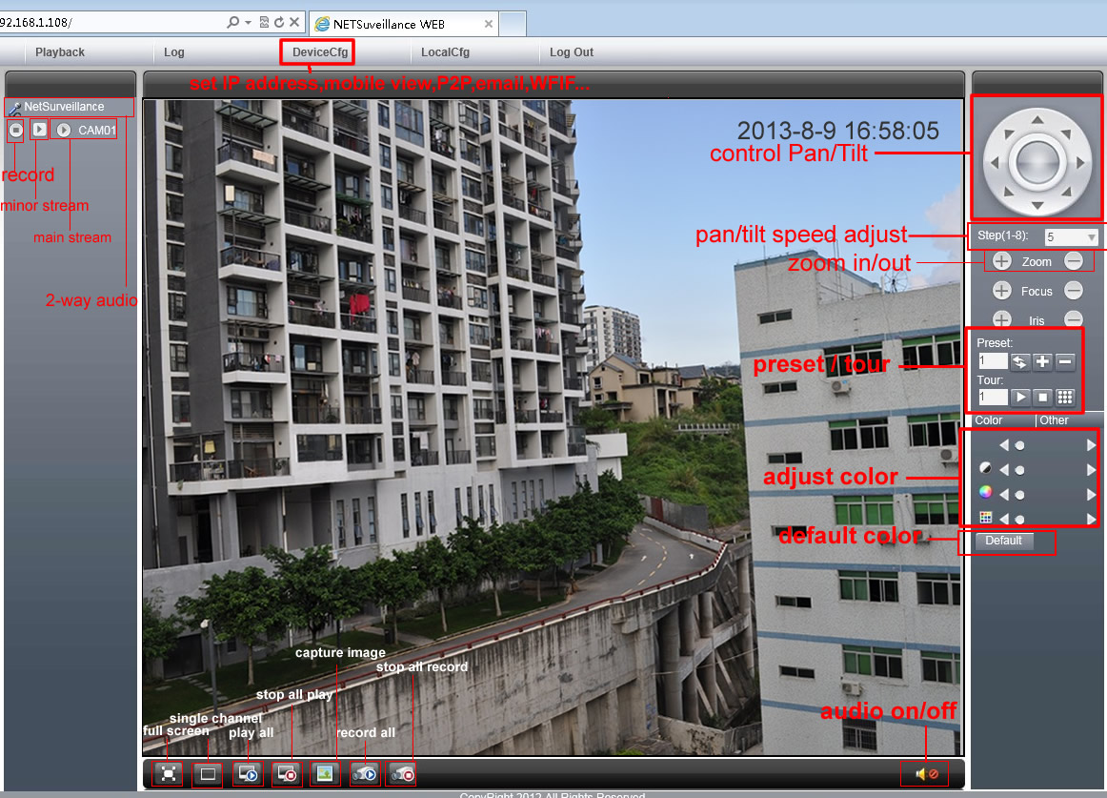
Above photo shows each button function on main interface of IE

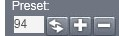 call preset#95:OSD menu #94:quit #99:auto rotate
click red area to call zoom camera OSD menu
set zoom, focus here, click preset #94 to quit setting

click DeviceCfg button to enter into camera setting
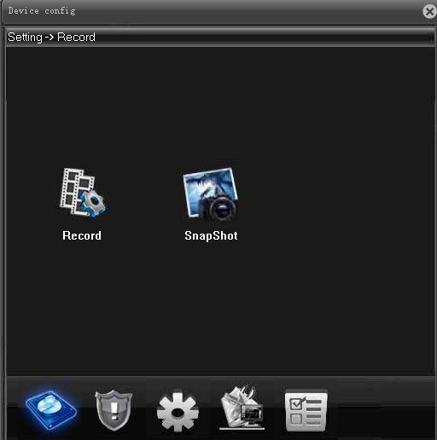
Setting:Record-Alarm-System-Advanced-Info,
Record:record, snapshot

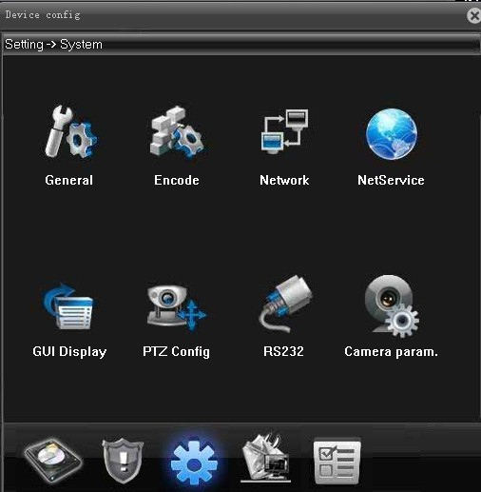

Click system to show system interface to set camera like above, the 1st icon is general setting.
click general setting icon

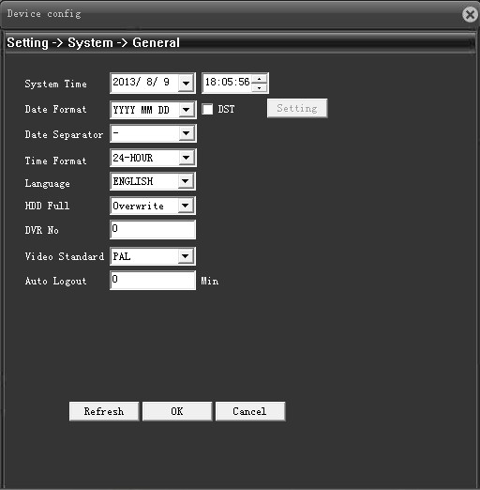
We can set time, lauguage and etc.
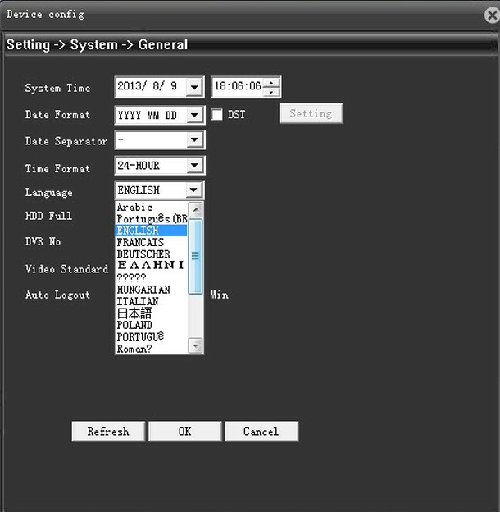

Support 20 languages, you can choose the language your area use.

Next, let’s go to see what have in NetService

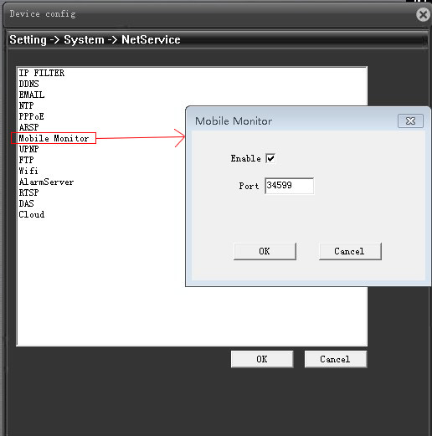
Click mobile monitor, tick enable, to enable mobile monitor, to view via mobile remotely.

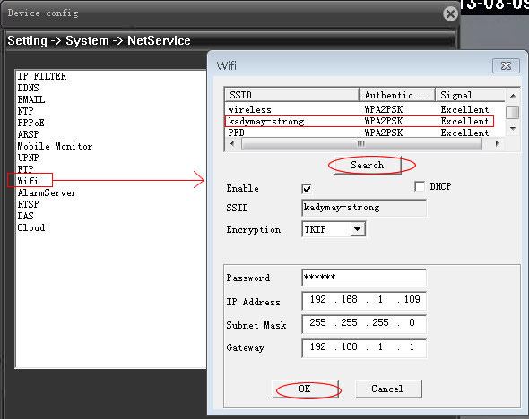
If the ip camera is WIFI, we need to go to Wifi setting. Click Search to search wifi signal, choose the wifi signal you need, input password, click OK. Now you can use WIFI.
Notice:if IP Camera is WIFI, there will be 2 IP address in search software in CMS. It’s normal, as one IP address belongs to wired network card, the other IP address belongs to wireless network card.

Following let’s click this iconto check camera P2P serial ID

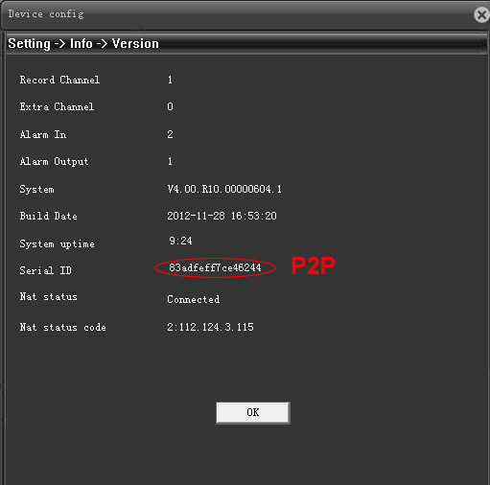
We can check out P2P (UPNP) code, it’s no need to make port forwarding via this code.
And directly view video in CMS software or mobile surveillance software, so easy.

