Welcome to use our IPC product.
Following is quick guide for CMS Software.

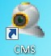click CMS icon enter into CMS management software
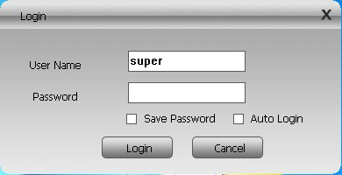
Default User Name:super password:none

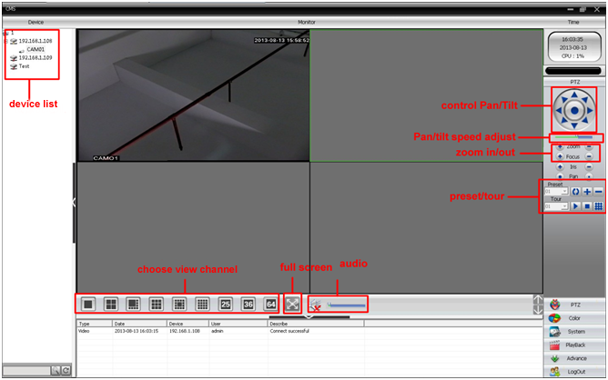
Above photo is main interface
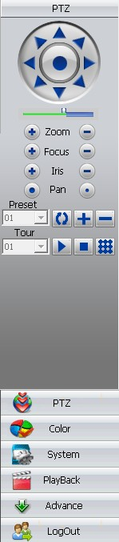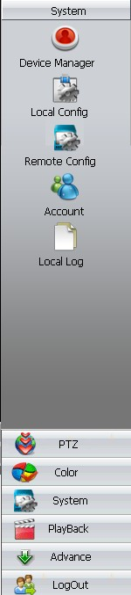
Above photos are “PTZ”,“System” interface

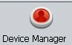click this icon to enter into “Device Manager”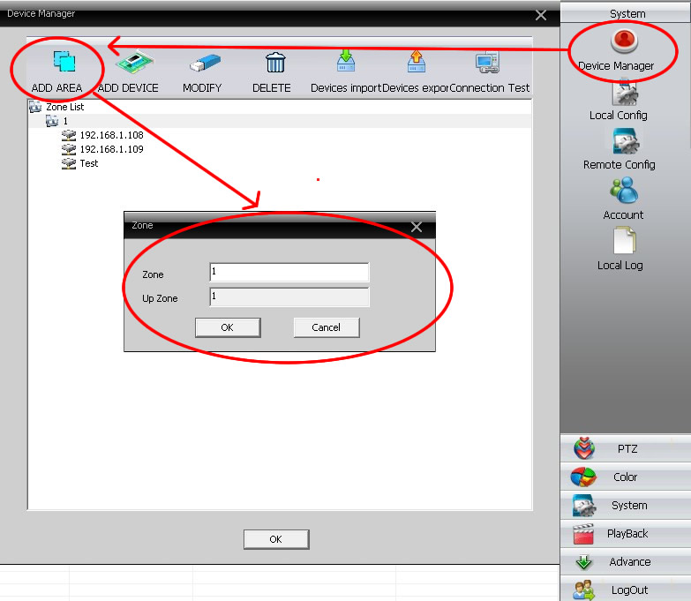
Step 1:click “ADD AREA” to add zone, then add device

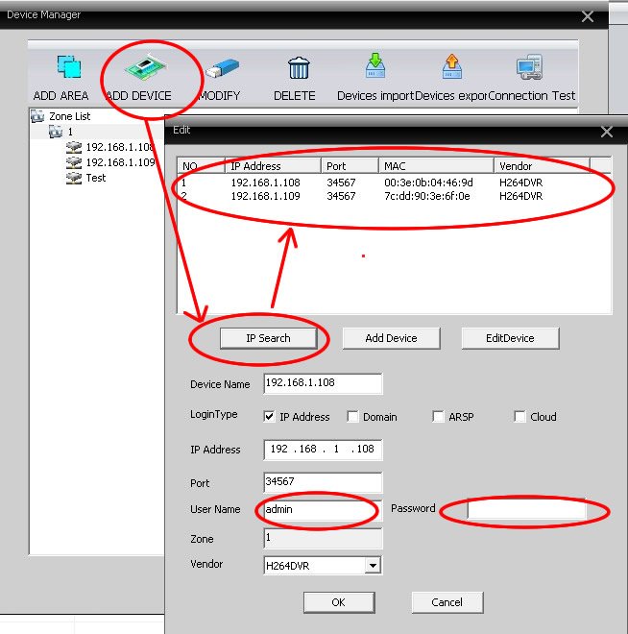
Step 2:“ADD DEVICE”-“IP Search” to Search out IP address-OK
Note:default User Name:admin password:none

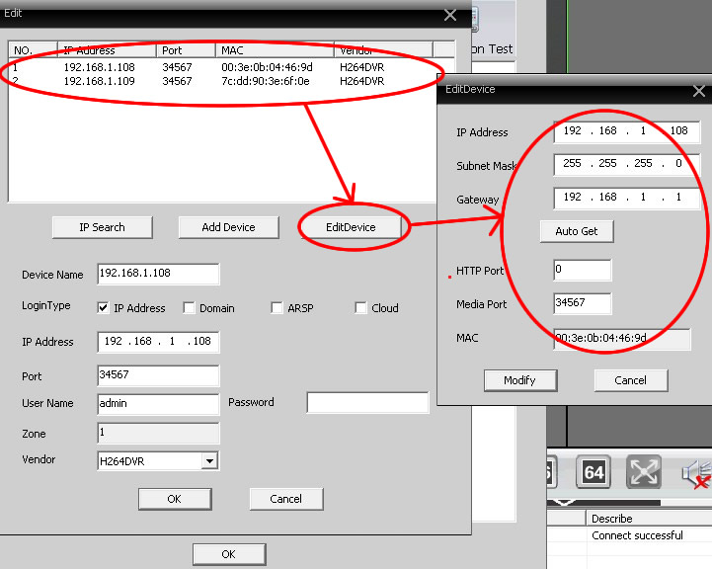
Click “EditDevice” to update IP address and port

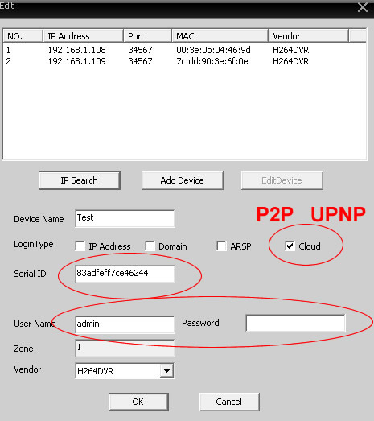
Cloud is P2P mode, input Serial ID to view
Note:default User Name:admin password:none

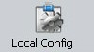click this icon to enter into “Local Config”
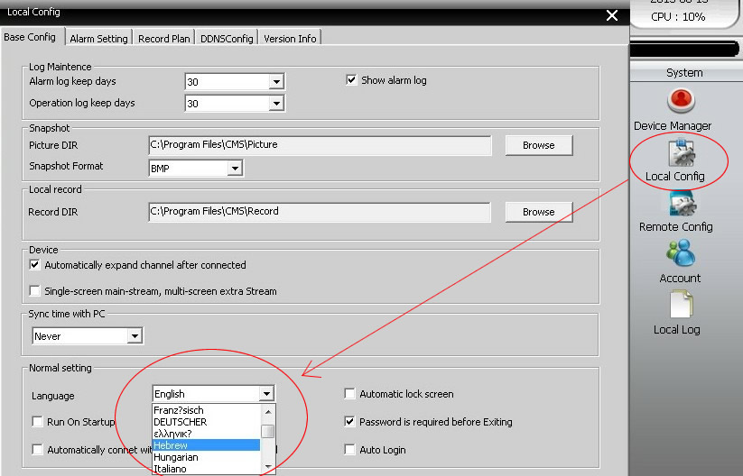
Set Language for CMS software(20 language for choice):
Arabic,Chinese,Dutch,English,French,Finnish,Hebrew,Hungarian,Italian,Japanese,Korean,Polish,Portuguese,Romanian,Russian, Spanish, Traditional Chinese,Turkish….

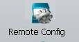click this icon to enter into “Remote Config”

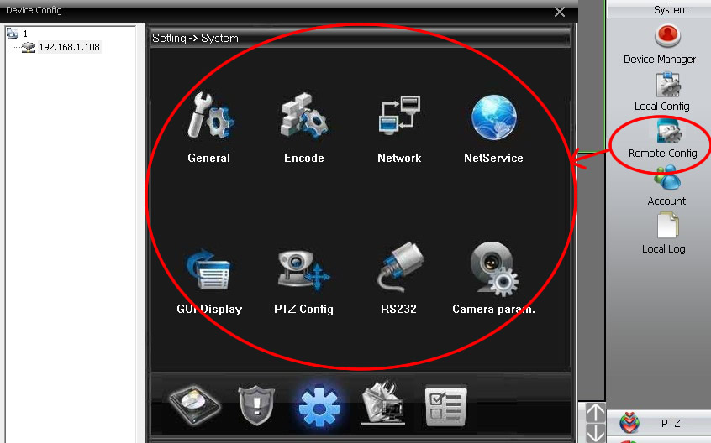

For Remote configure, please refer to IE Quick Manual

